**Jenkins Task -4**

**1) Setup jenkins CICD pipeline using freestyle job using Docker containers using below code.**[**https://github.com/betawins/hiring-app.git**](https://github.com/betawins/hiring-app.git) **Stages:  
   1) Git Clone  
   2) Sonarqube Integration  
   3) Maven Compilation  
   4) Nexus Artifactory  
   5) Slack Notification  
   6) Deploy On tomcat**

**Launch 4 Instances**

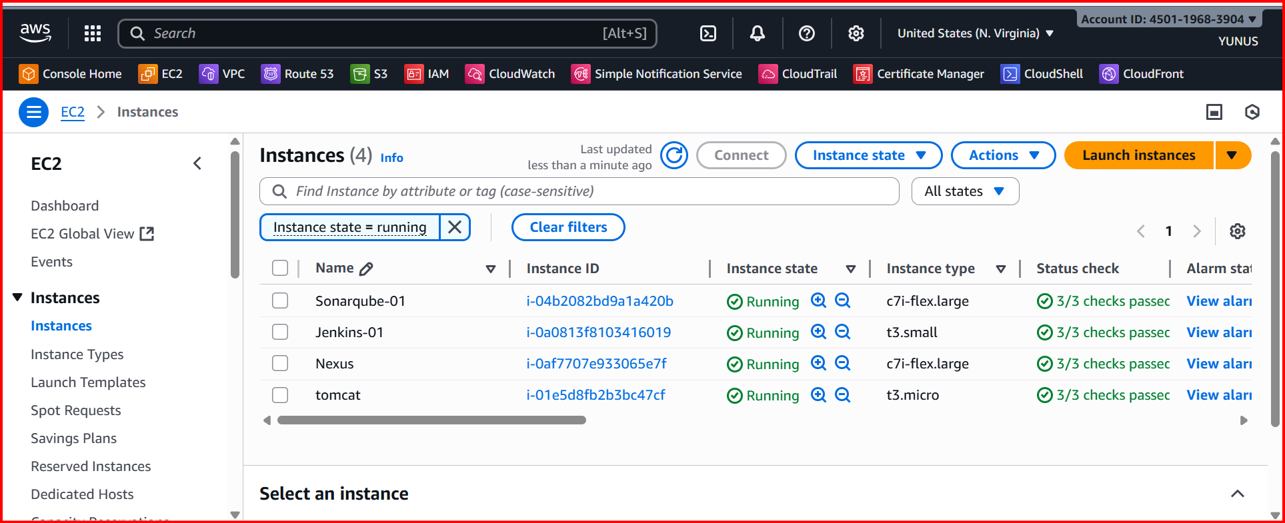

**IN JENKINS SERVER**

sudo dnf install -y java-17-amazon-corretto

java -version

sudo wget -O /etc/yum.repos.d/jenkins.repo \https://pkg.jenkins.io/redhat-stable/jenkins.repo

sudo rpm --import https://pkg.jenkins.io/redhat-stable/jenkins.io-2023.key

Imports Jenkins signing key.

Ensures that the packages downloaded from Jenkins repo are trusted and not

sudo yum clean all

sudo yum install jenkins -y

systemctl start jenkins

systemctl status Jenkins

<http://3.84.81.205:8080/>

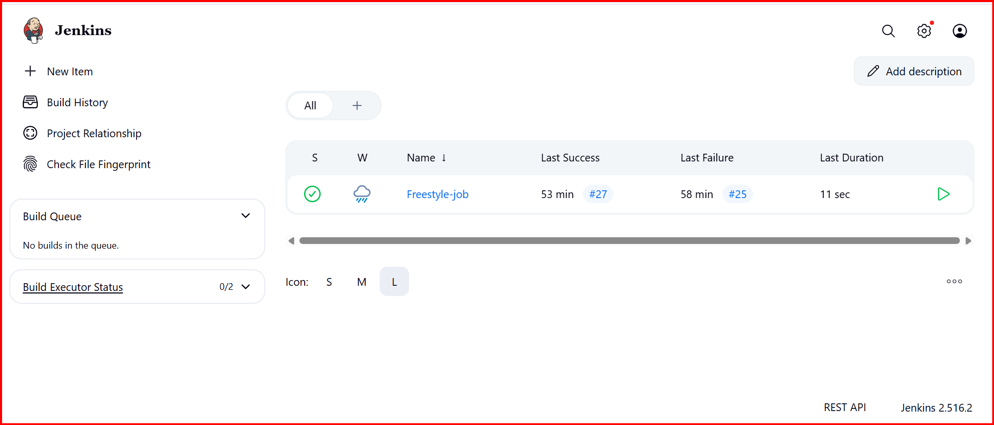

**In Sonarqube server install sonarqure**

BY USING DOCKER INSTAED SONARQUB

Sudo Su-

yum -y install docker

systemctl start docker

docker pull sonarqube

docker images

docker run -itd --name sonarqube -p 9000:9000 sonarqube

docker ps

<http://54.211.241.8:9000/>

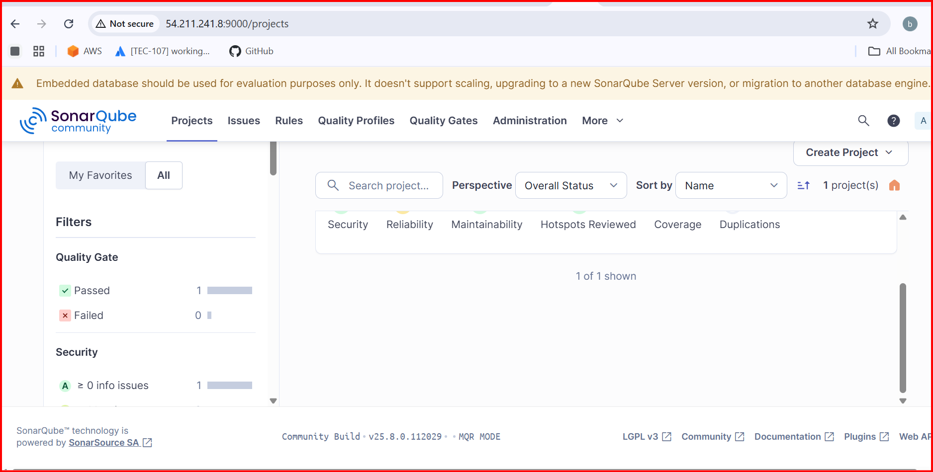

**Install Sonarscanner plugin**

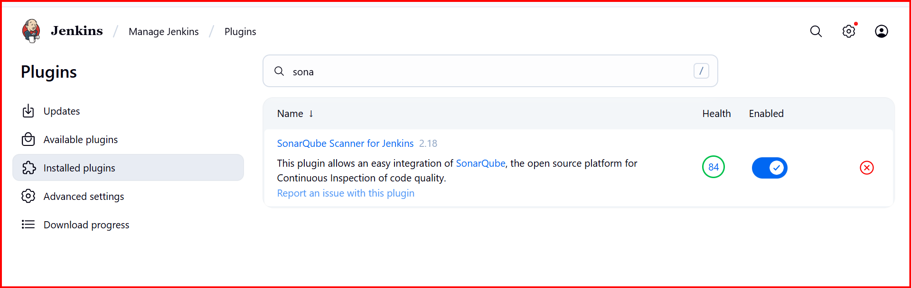

**Configure Jenkins to sonarscanner**

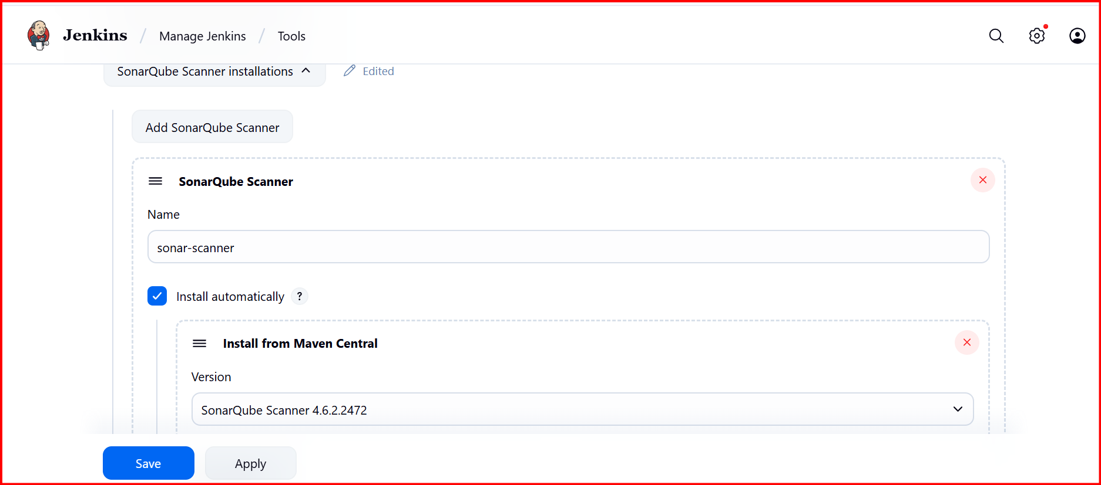

**Configure Jenkins to sonarqube**

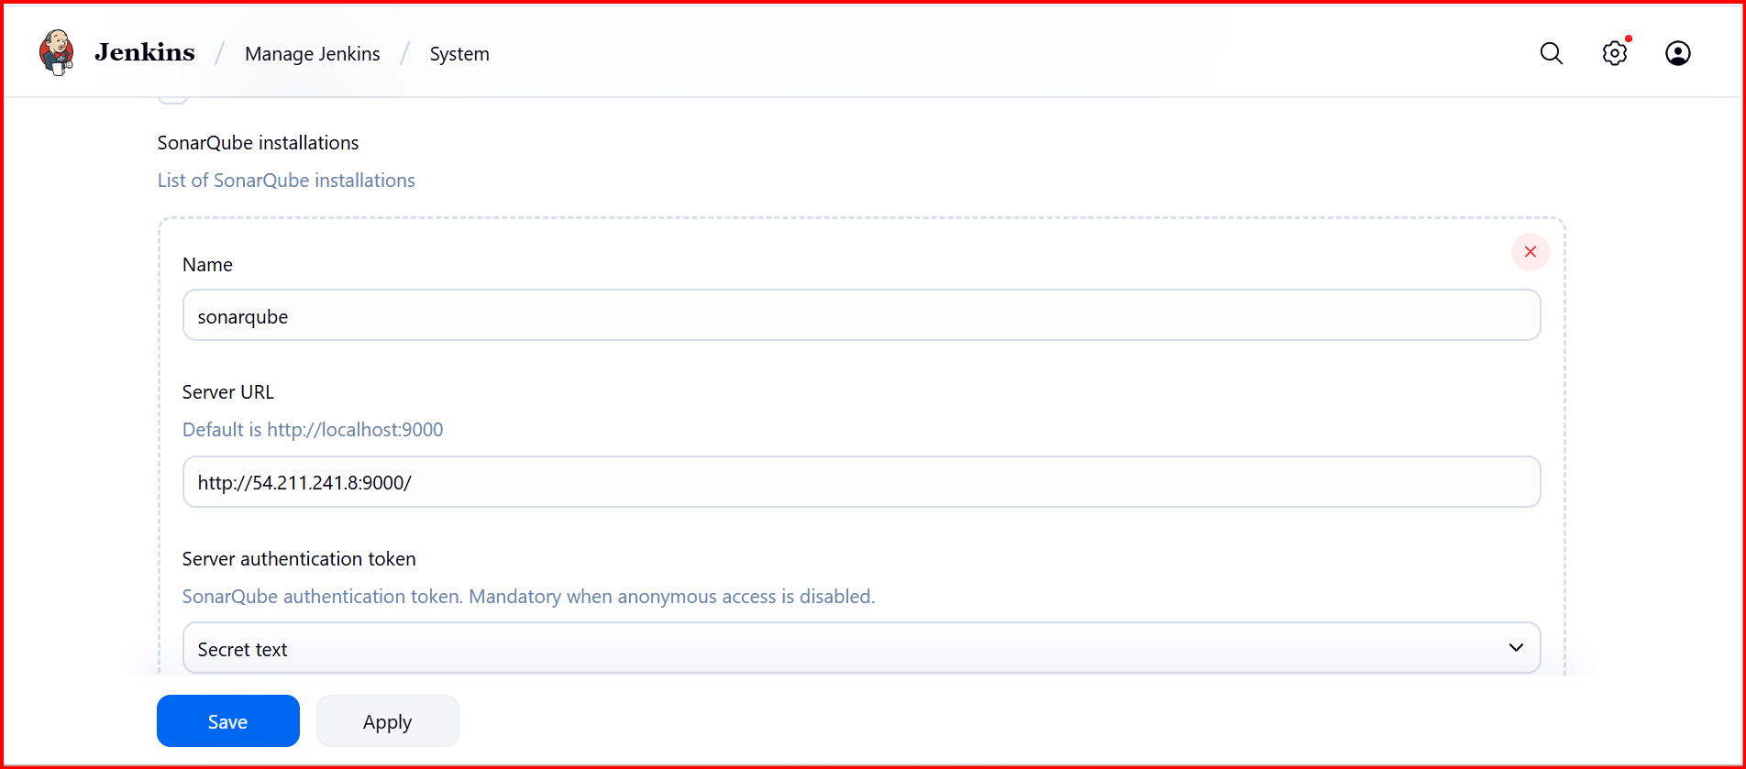

In Job configuration

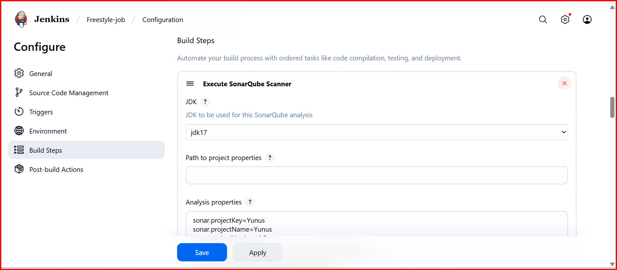

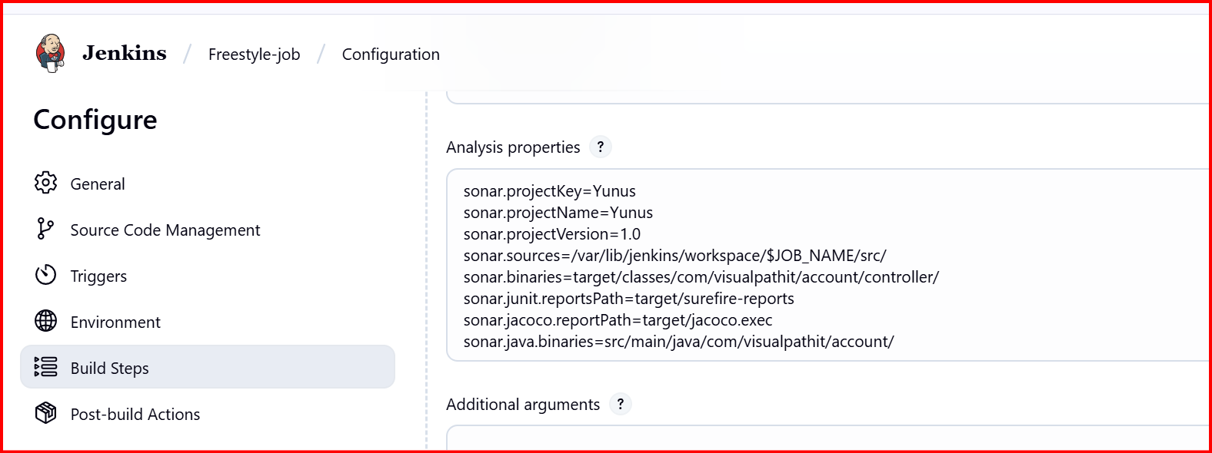

**I have Install maven in Jenkins server**

cd /opt/

ls

google maven download click first link select tar.gz

wget https://dlcdn.apache.org/maven/maven-3/3.9.11/binaries/apache-maven-3.9.11-bin.tar.gz

tar xvf apache-maven-3.9.11-bin.tar.gz

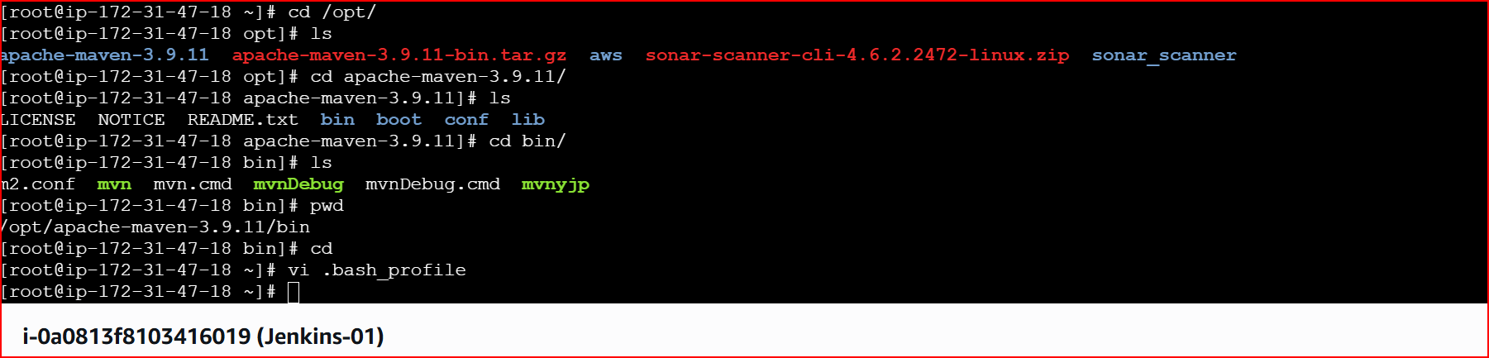

Edit this file

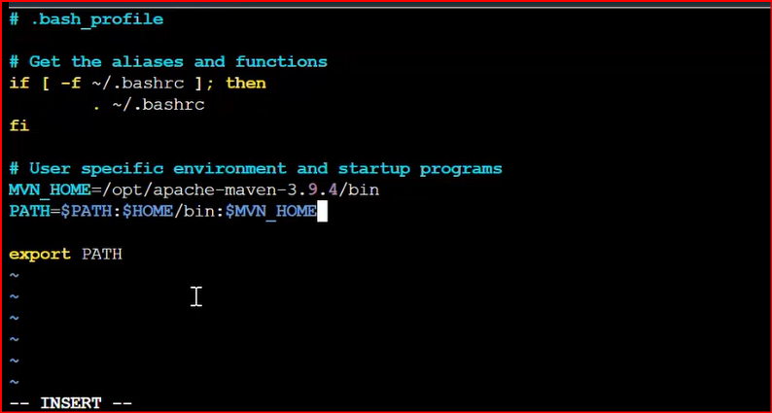

**Go to this location 🡪/opt/apache-maven-3.9.11/bin**

**source ~/.bash_profile --> RESTART THE FILE**

**echo $MVN_HOME --> TO FIND THE PATH**

**mvn –version**

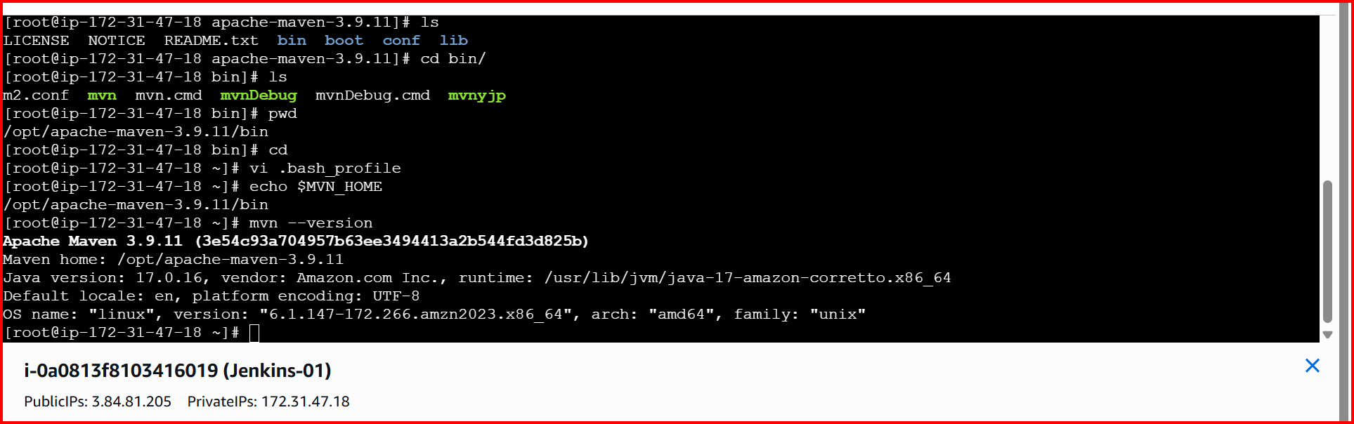

**Install Maven plugin**

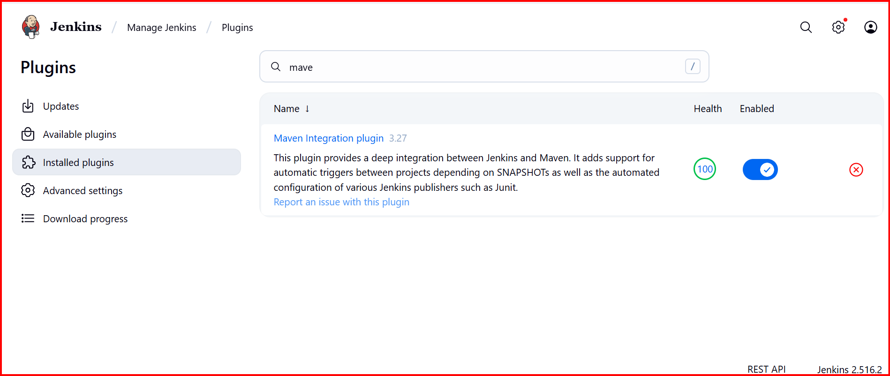

**Configure the maven in Jenkins**

**Give the maven path**

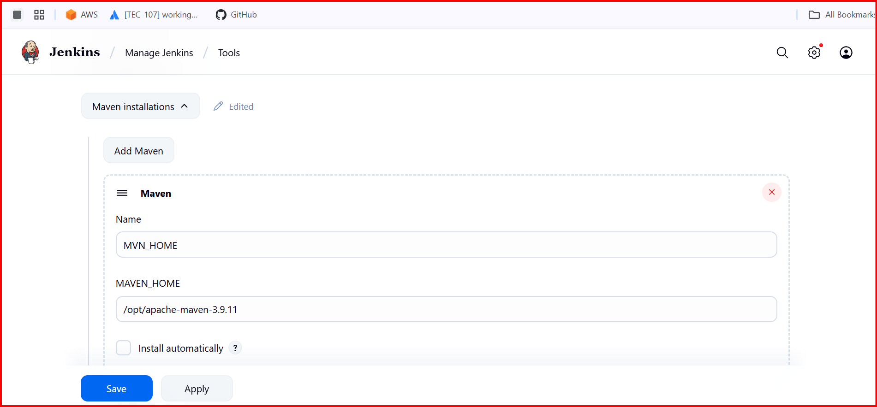

**In job configurations**

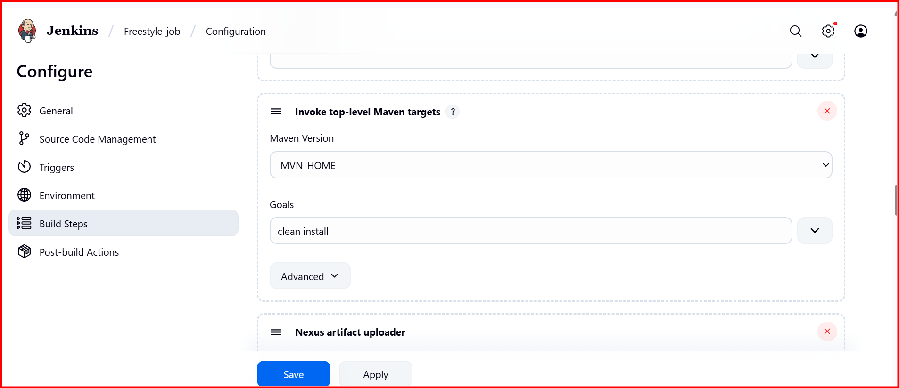

**Nexus**

**wget https://sonatype-download.global.ssl.fastly.net/nexus/3/nexus-3.0.2-02-unix.tar.gz**

**tar -zxvf nexus-3.0.2-02-unix.tar.gz**

**mv /opt/nexus-3.0.2-02 /opt/nexus**

**cd nexus/**

**vi nexus.rc**

**run_as_user="ec2-user"**

**exit**

**cd**

**sudo chown -R ec2-user:ec2-user nexus**

**cd nexus/**

**cd bin/**

**./nexus start**

**./nexus status** [**http://3.81.169.50:8081/**](http://3.81.169.50:8081/)

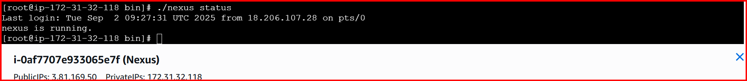

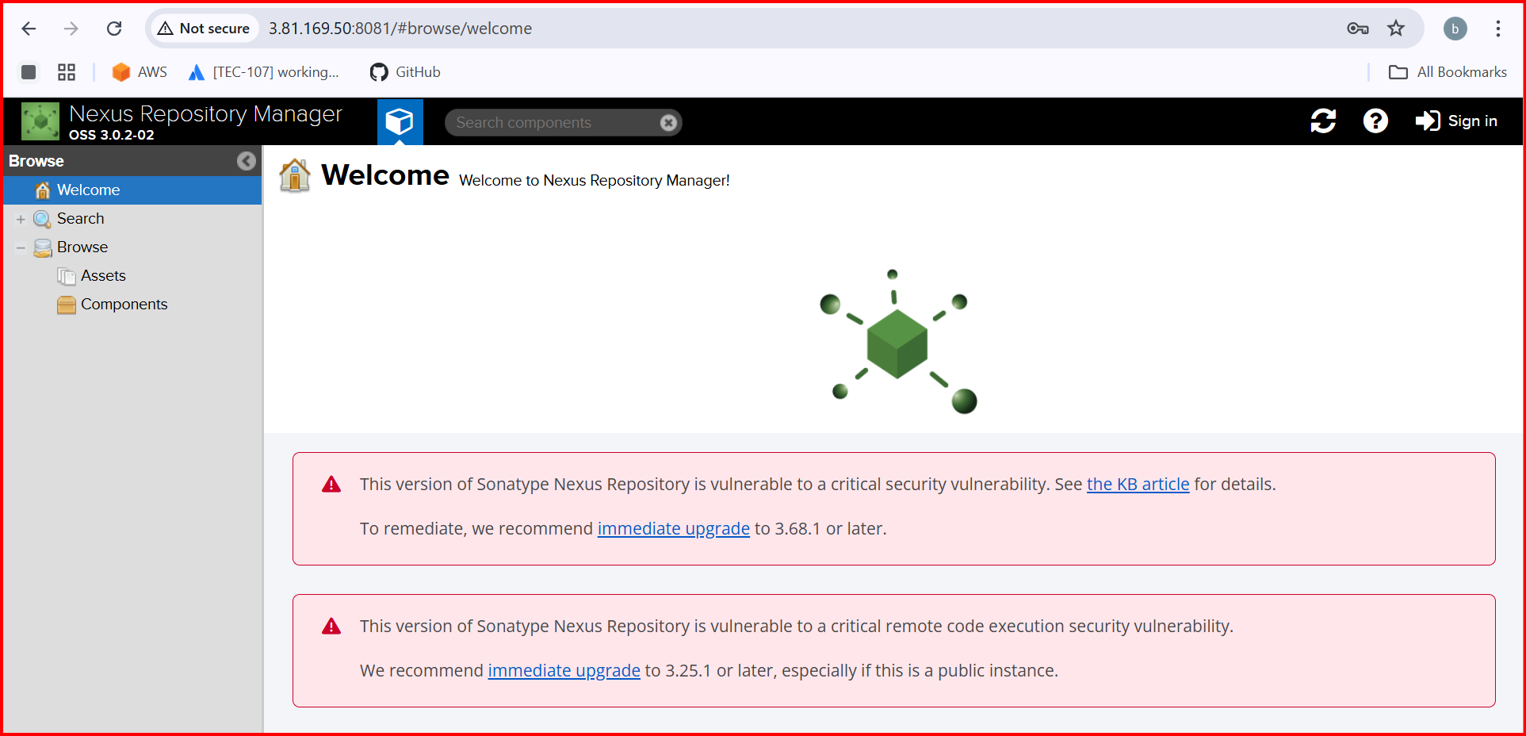

**Nexus --> Settings --> Repositories --> create repo --> Maven2hosted -->**

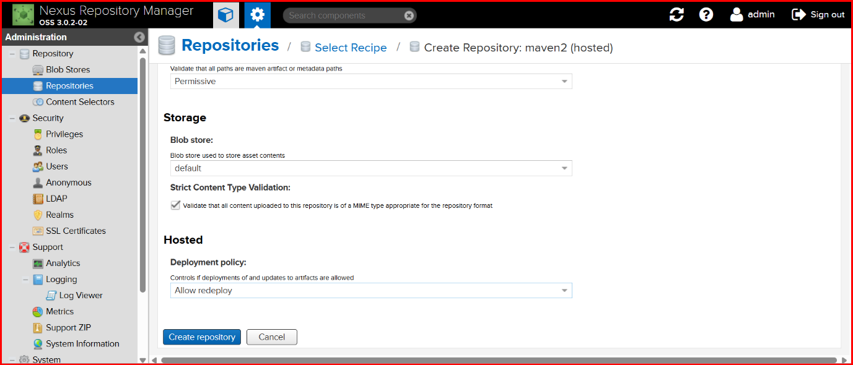

**Install nexus plugin**

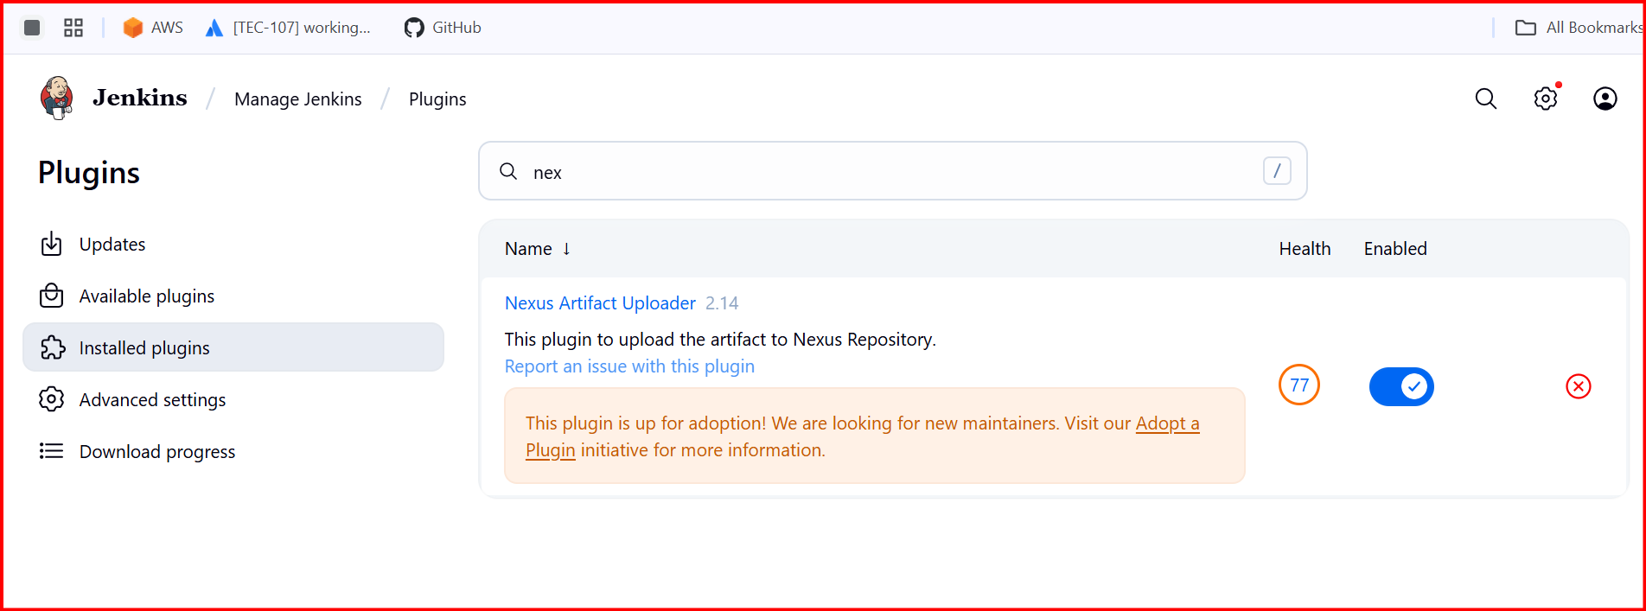

**Job configuration**

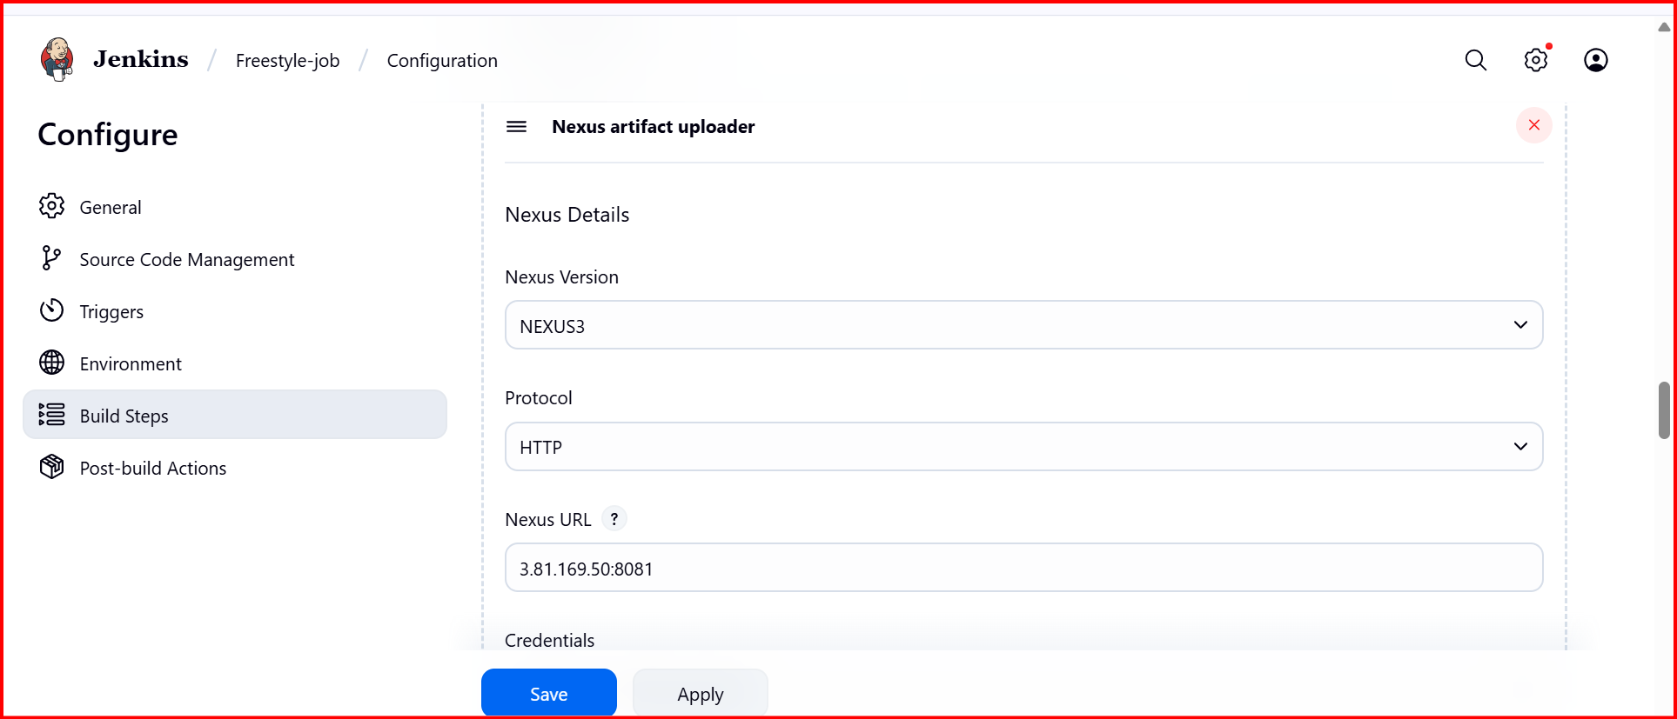

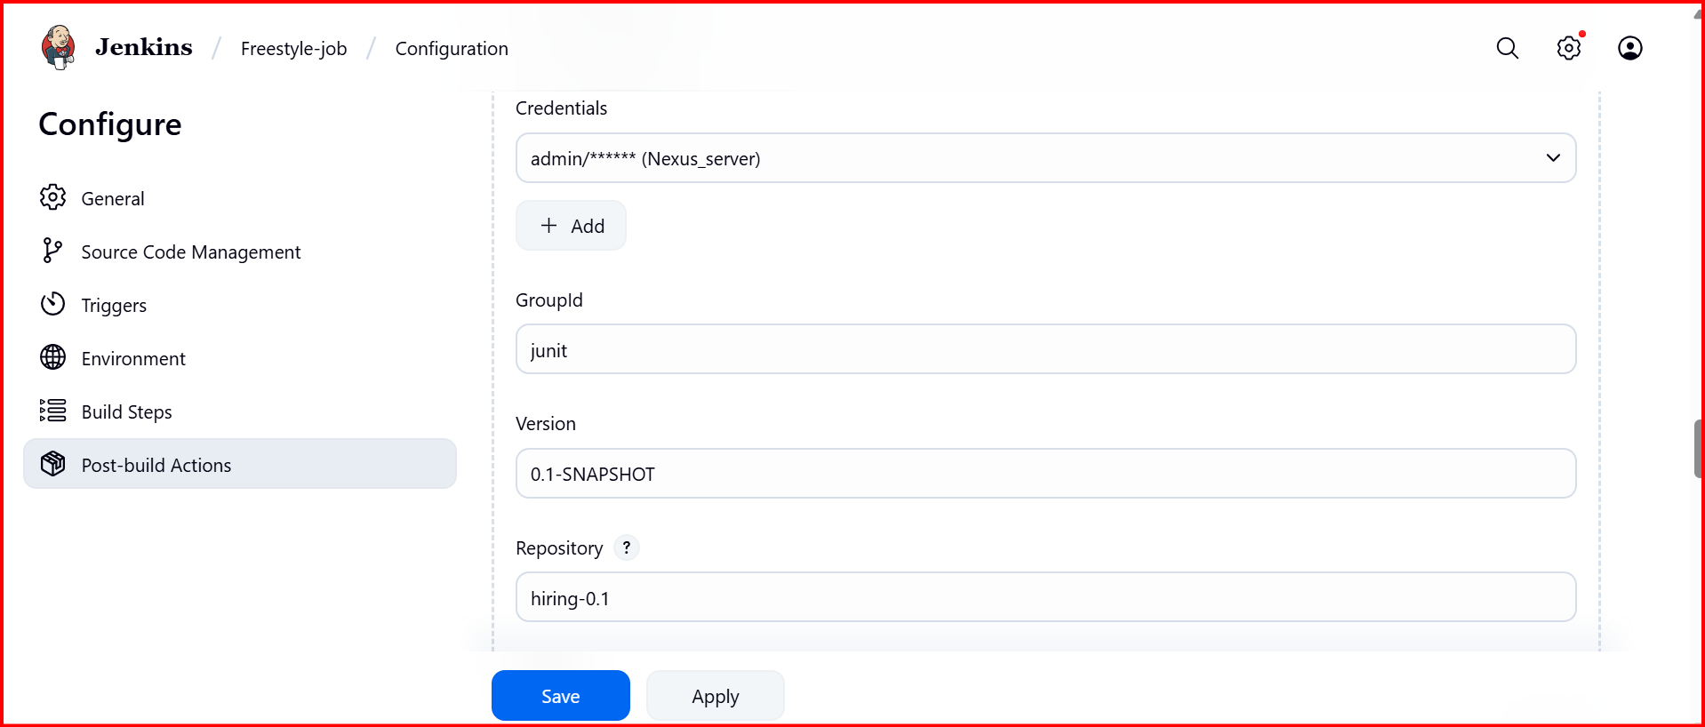

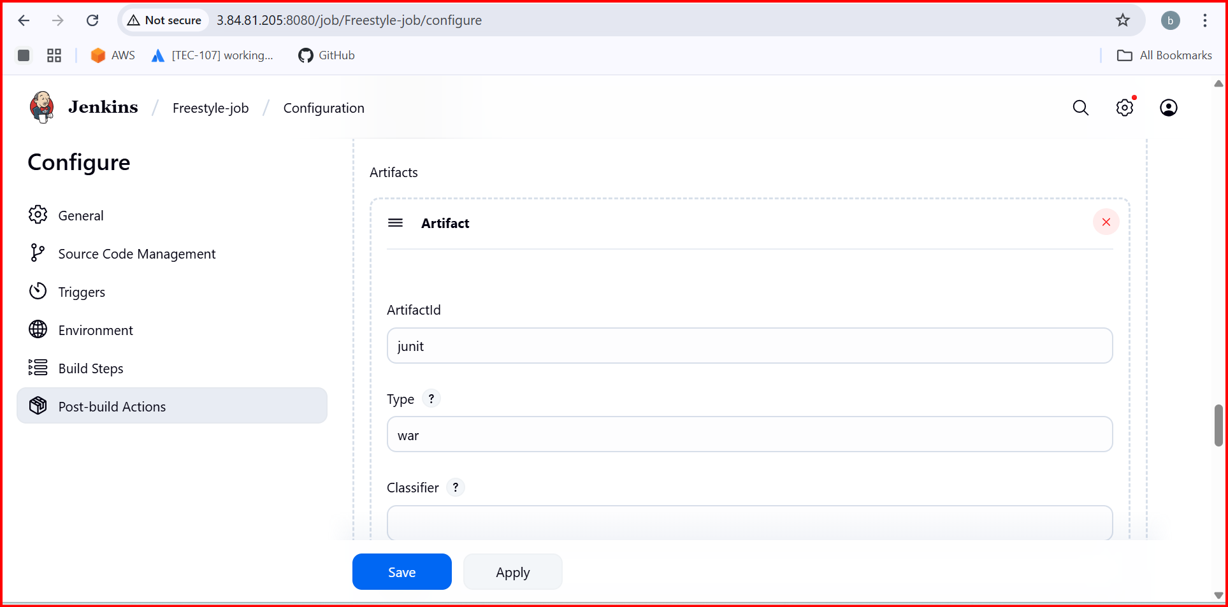

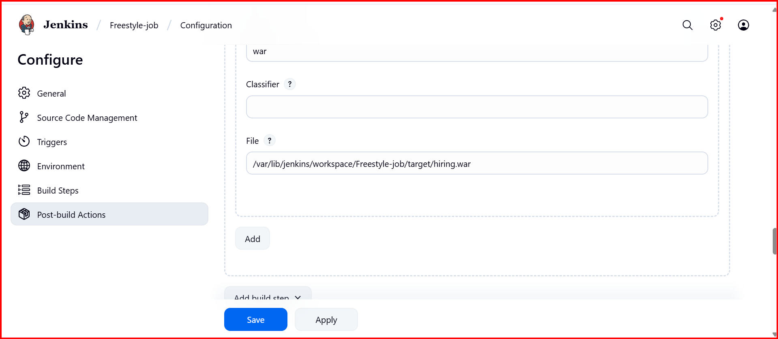

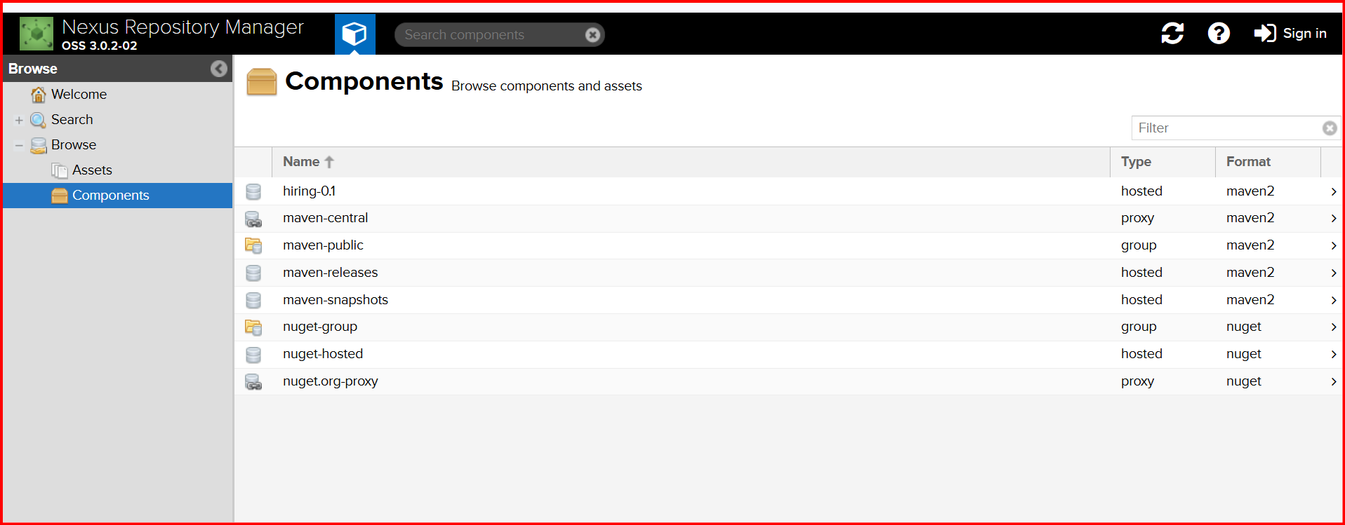

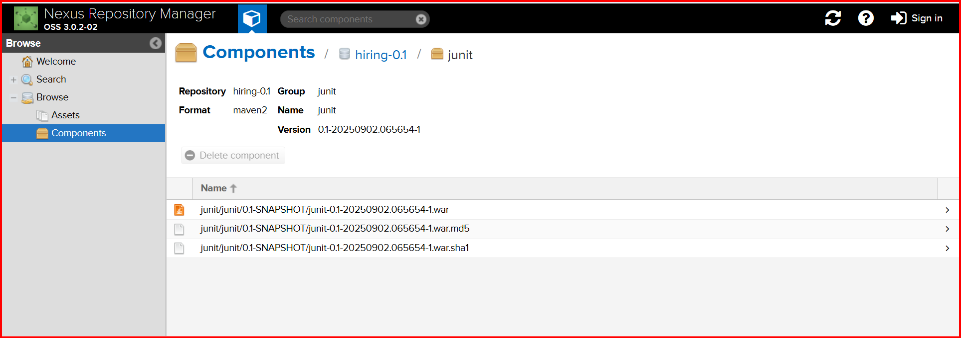

**Tomcat install in Tomcat server**

**yum install java-1.8\***

**wget https://dlcdn.apache.org/tomcat/tomcat-9/v9.0.108/bin/apache-tomcat-9.0.108.tar.gz**

**tar xvf apache-tomcat-9.0.108.tar.gz**

**cd apache-tomcat-9.0.108/**

**cd bin/**

**ls**

**bash startup.sh**

**tar xvf apache-tomcat-9.0.108.tar.g**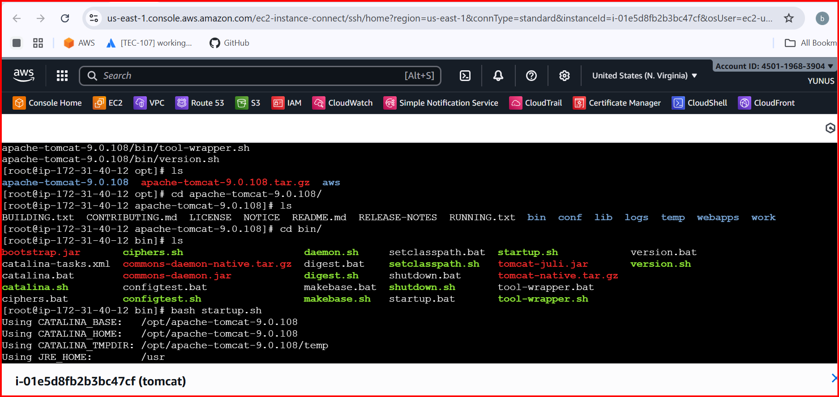

**find / -name context.xml**

**4 files will be avalible we can edit the files file value there <!-- -->**

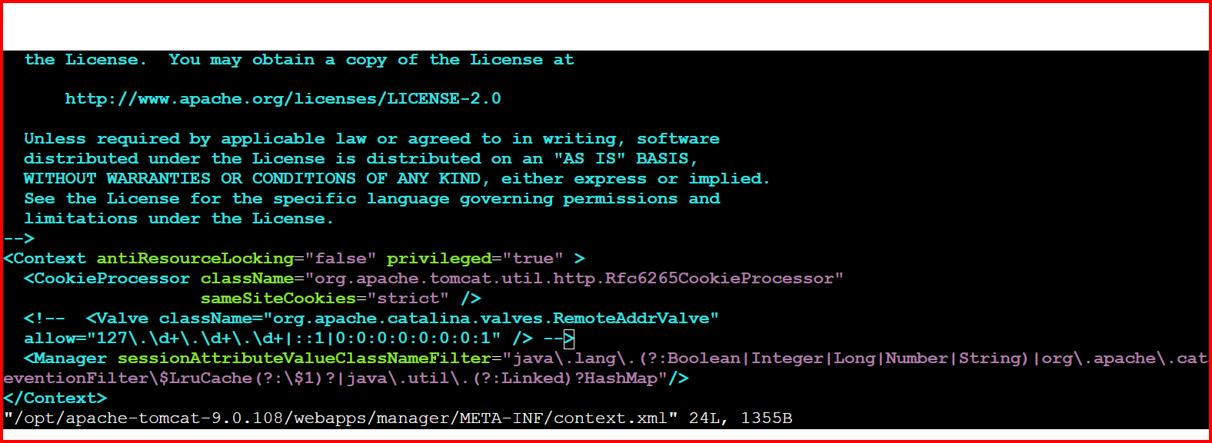

**Find Valve then edit <!-- last -- > like this do for all the steps**

**[root@ip-172-31-40-12 apache-tomcat-9.0.108]# cd conf/**

**vi tomcat-users.xml**

**<role rolename="manager-gui"/>**

**<role rolename="manager-script"/>**

**<role rolename="manager-jmx"/>**

**<role rolename="manager-status"/>**

**<user username="admin" password="admin" roles="manager-gui, manager-script, manager-jmx, manager-status"/>**

**<user username="deployer" password="deployer" roles="manager-script"/>**

**<user username="tomcat" password="s3cret" roles="manager-gui"/>**

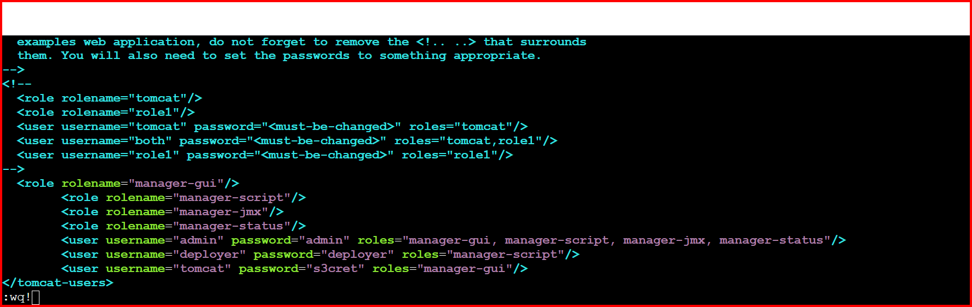

[**http://3.89.73.62:8080/**](http://3.89.73.62:8080/)

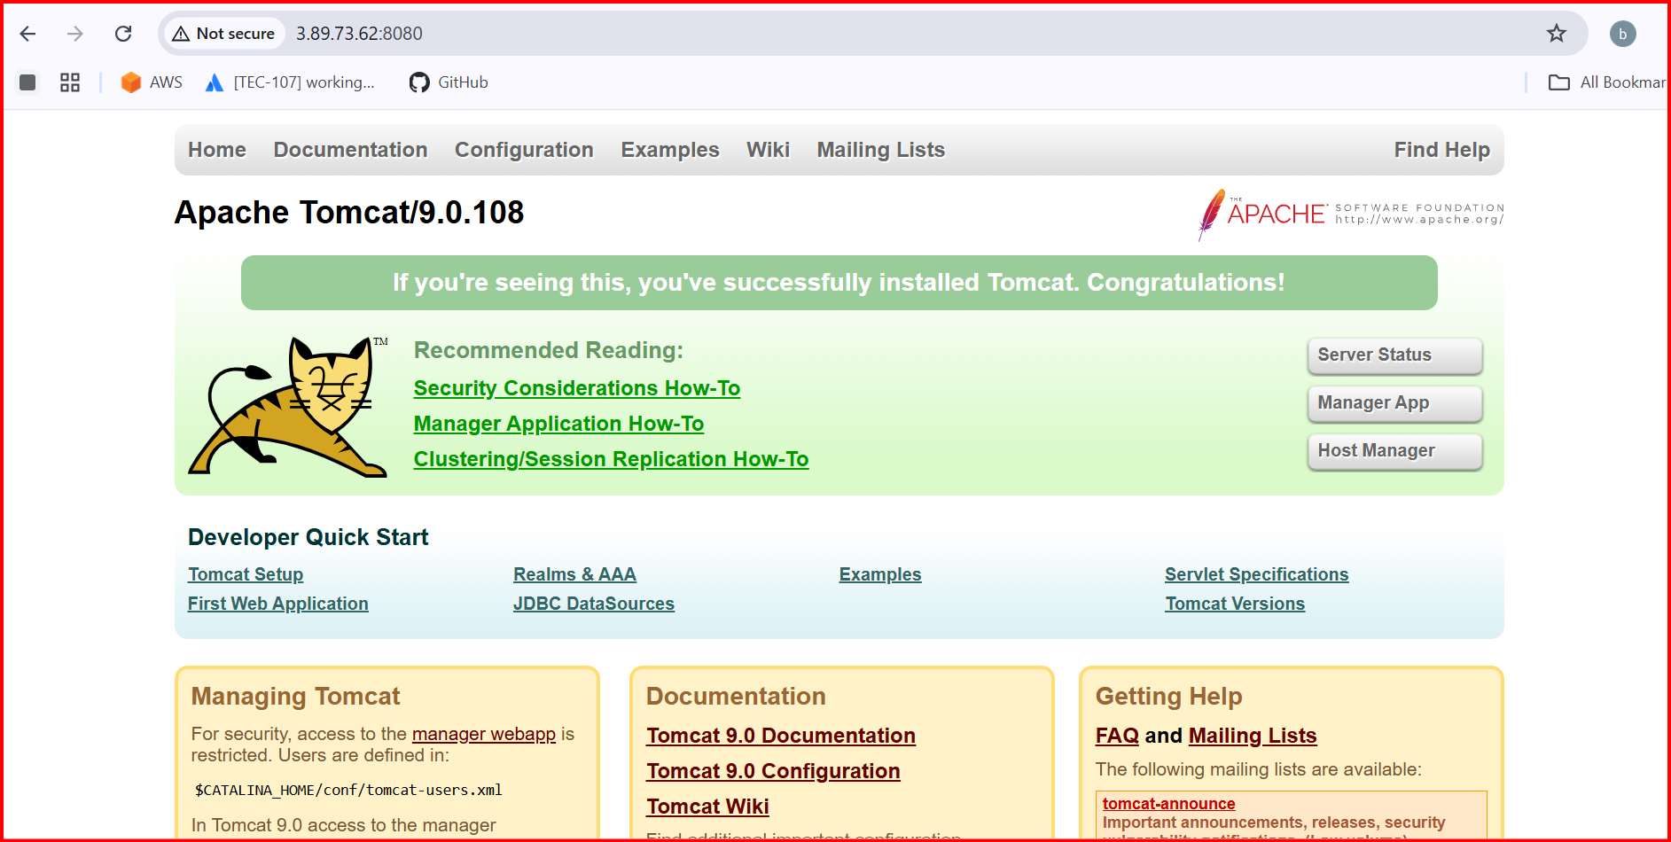

**Click any thing it will ask login password**

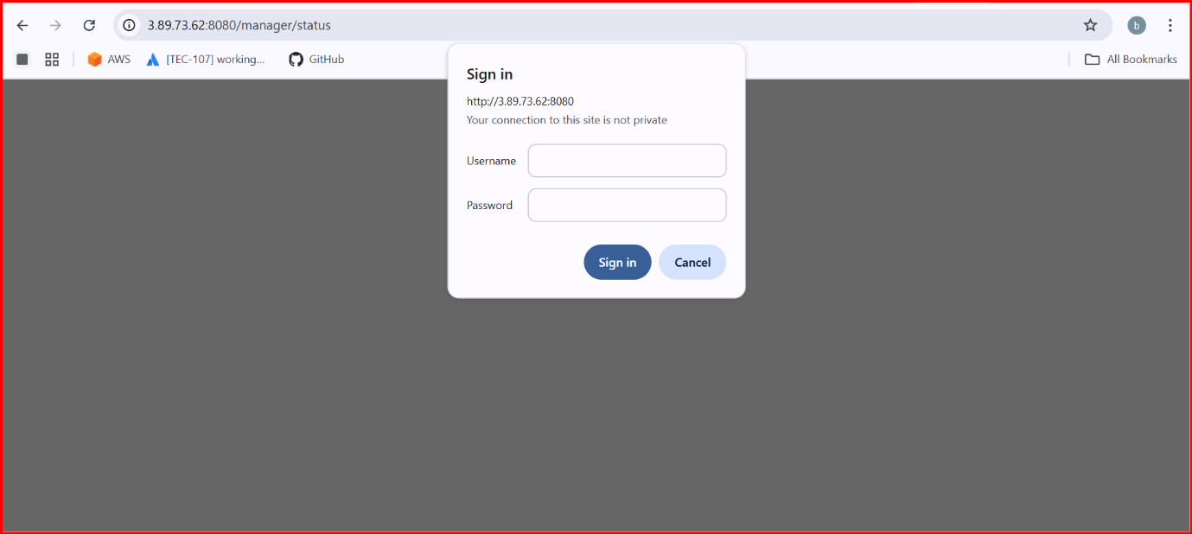

**Username :** **deployer**

**Password: deployer**

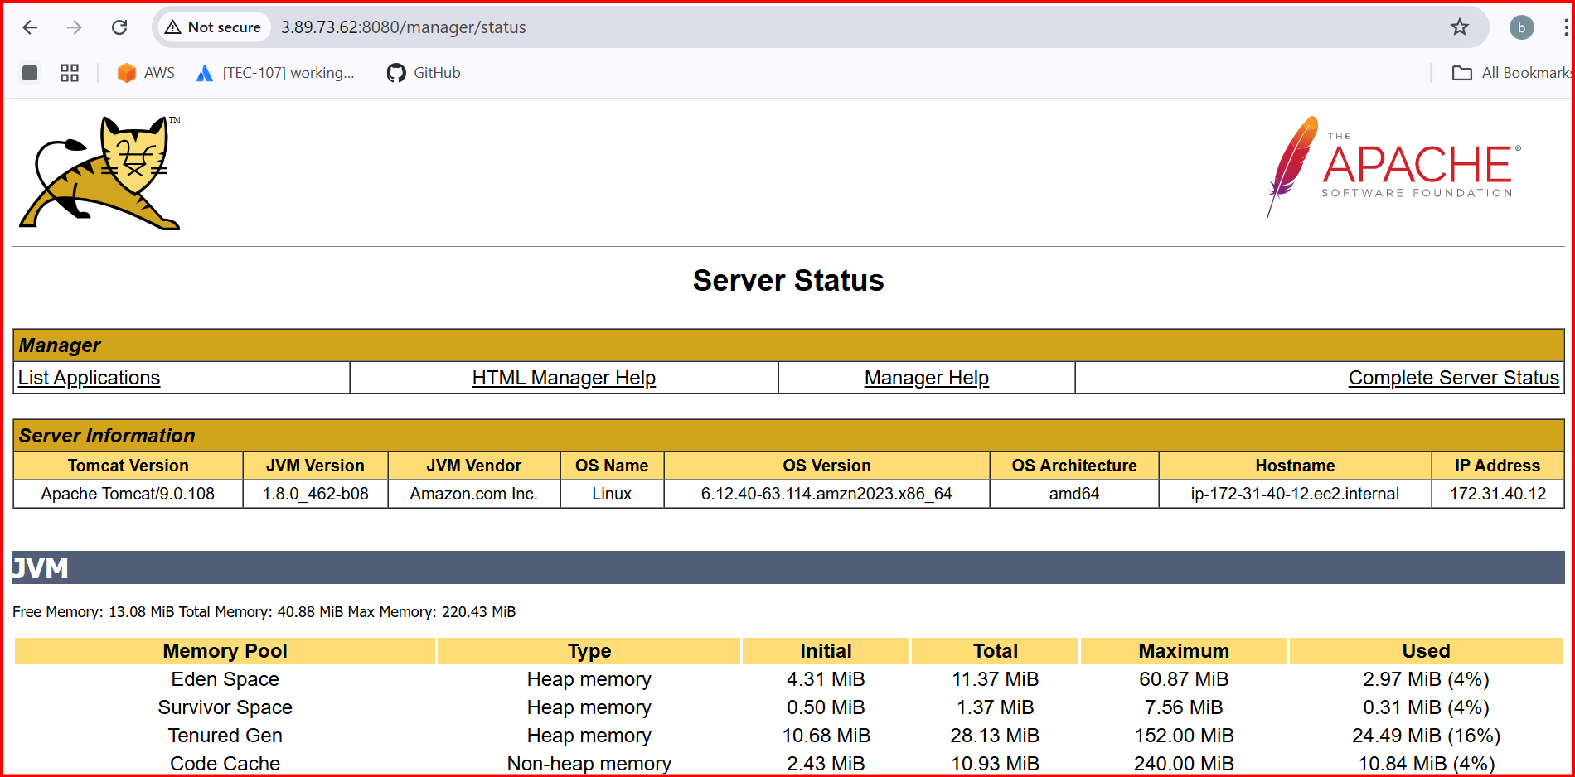

**Install deploy to container plugin**

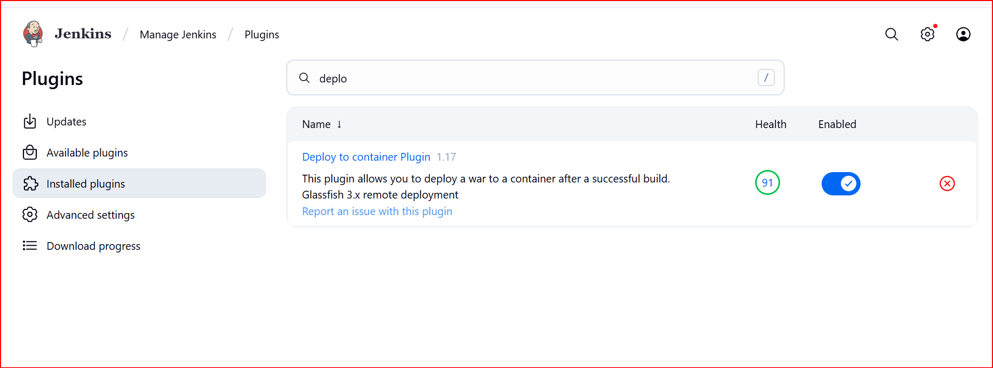

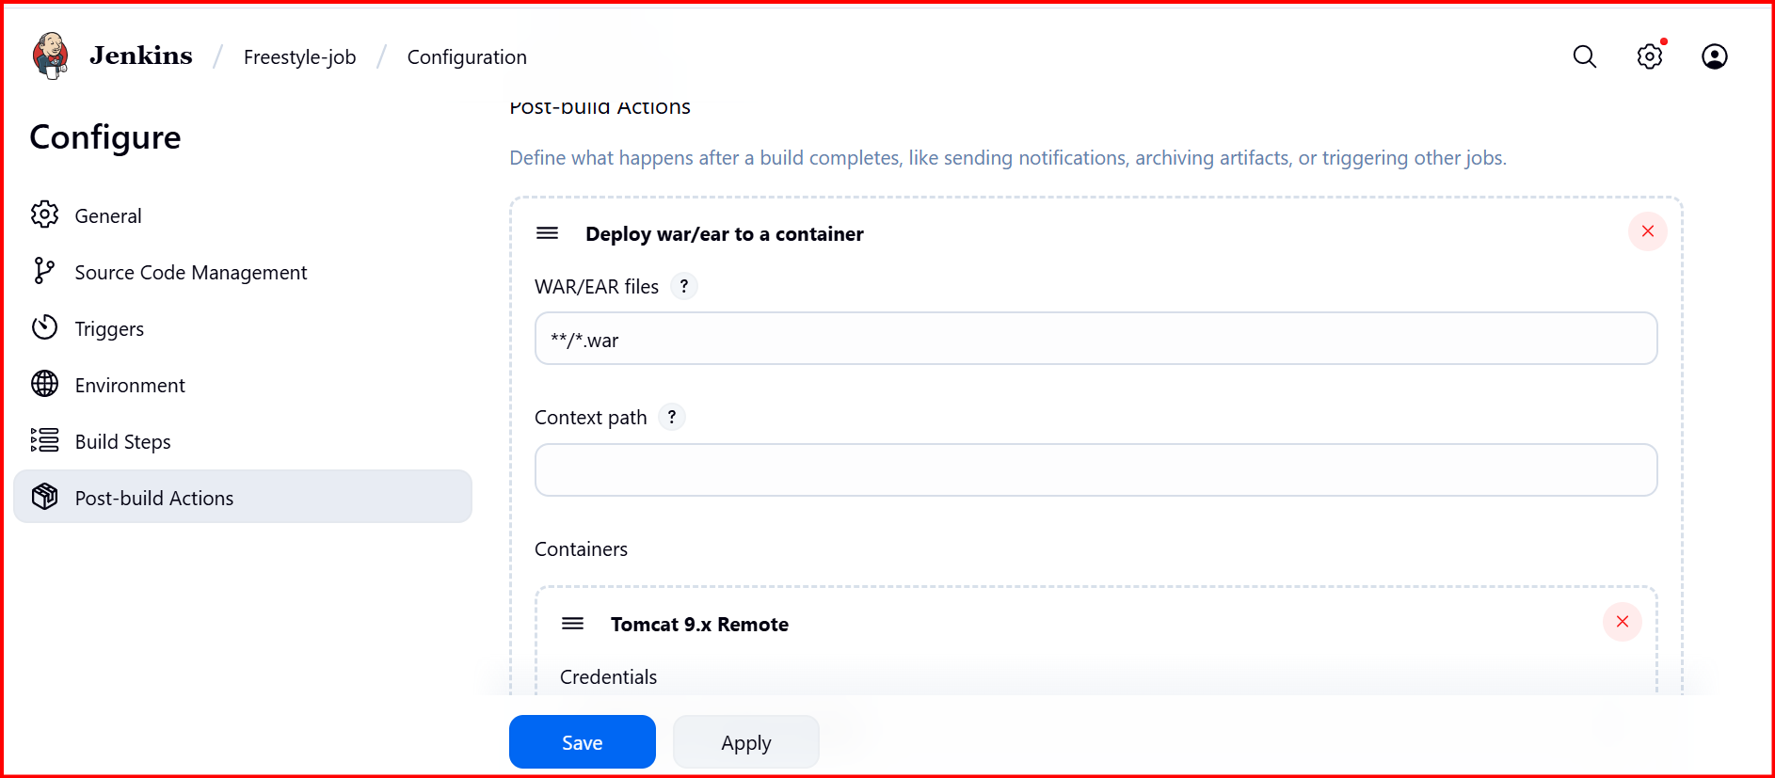

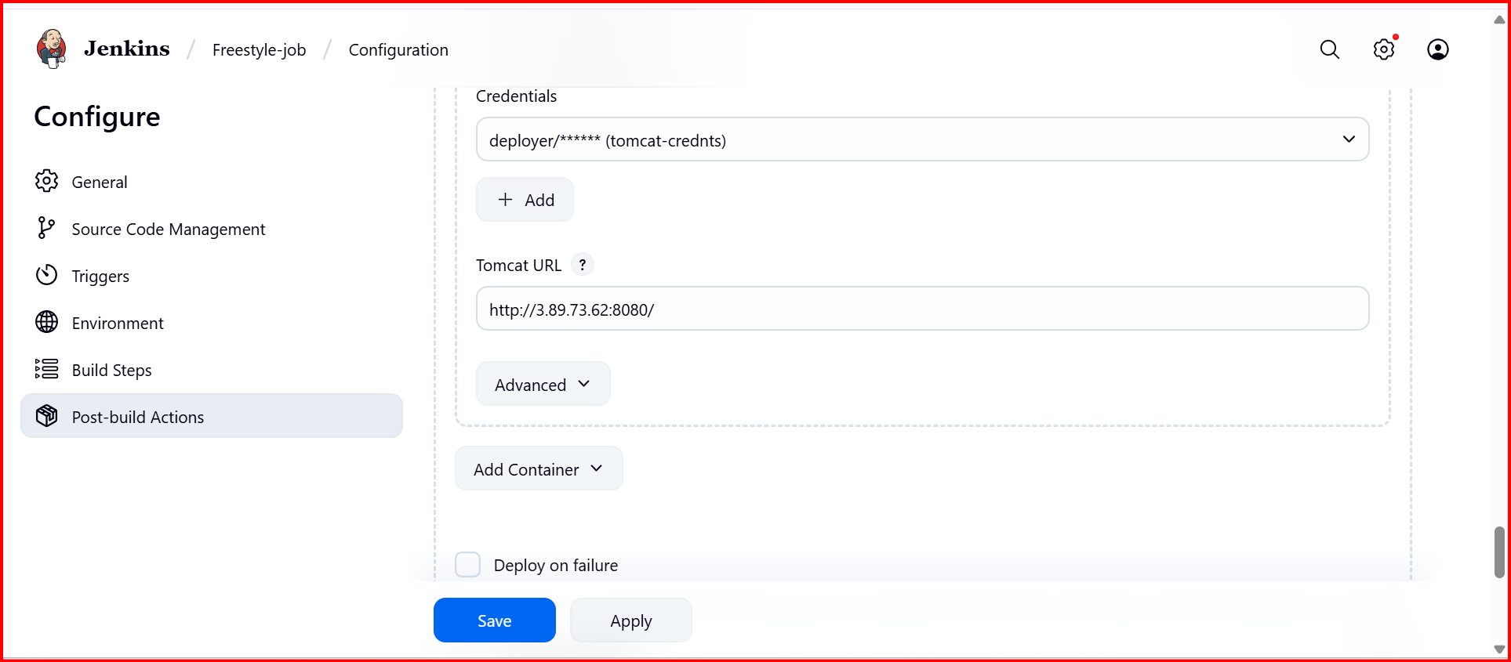

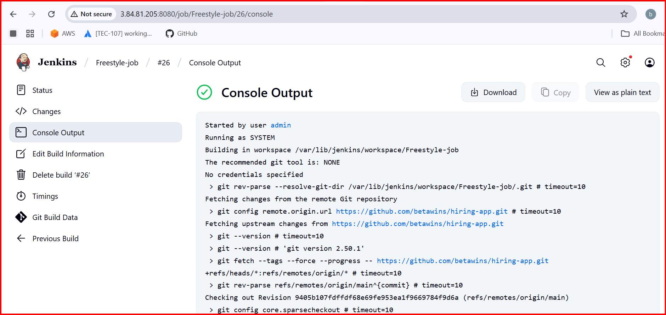

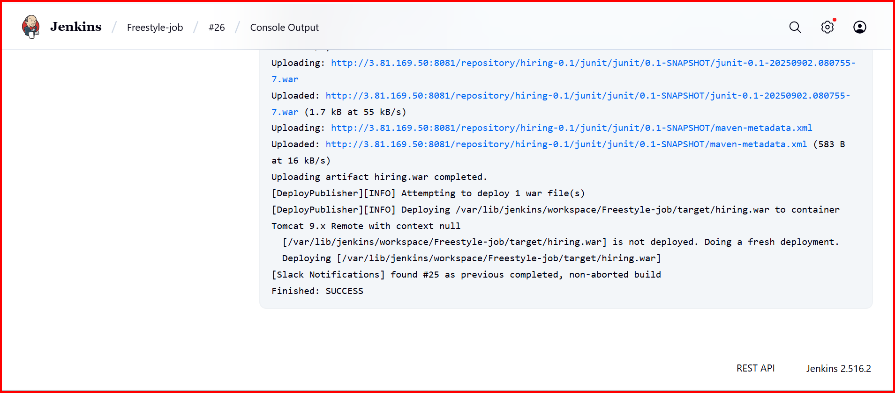

[**http://3.89.73.62:8080/hiring/**](http://3.89.73.62:8080/hiring/)

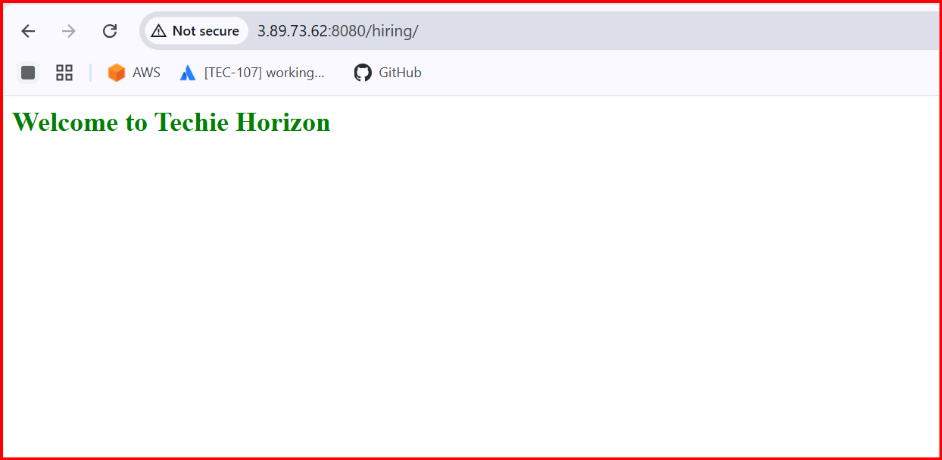

**2) Setup a jenkins CICD pipeline using Declarative pipeline using feature-1.1 branch.**[**https://github.com/betawins/sabear_simplecutomerapp/tree/feature-1.1**](https://github.com/betawins/sabear_simplecutomerapp/tree/feature-1.1) **stages:  
   1) Git Clone  
   2) Sonarqube Integration  
   3) Maven Compilation  
   4) Nexus Artifactory  
   5) Slack Notification  
   6) Deploy On tomcat**

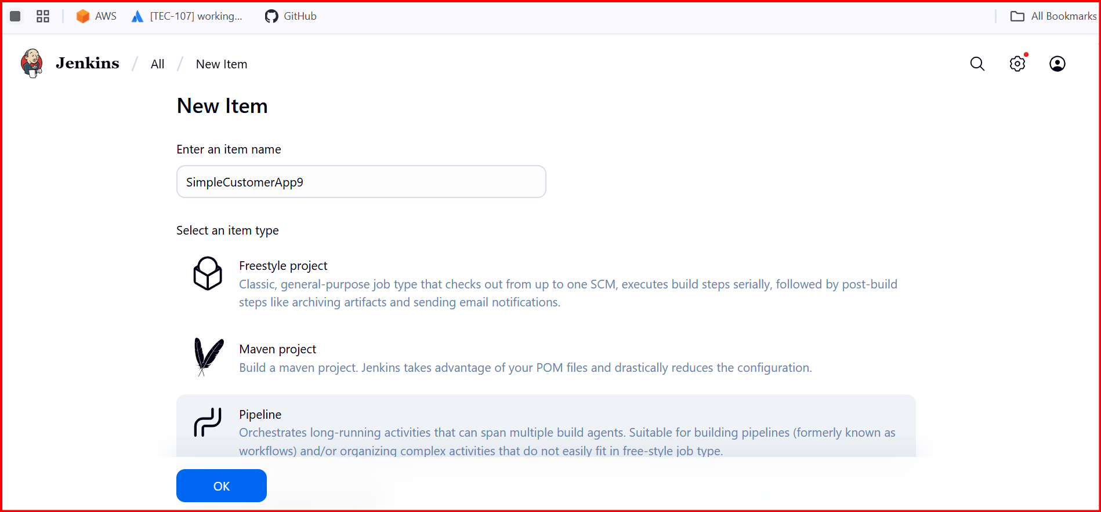

**Select pipeline**

[**https://github.com/Shaik123-hu/sabear_simplecutomerapp.git**](https://github.com/Shaik123-hu/sabear_simplecutomerapp.git)

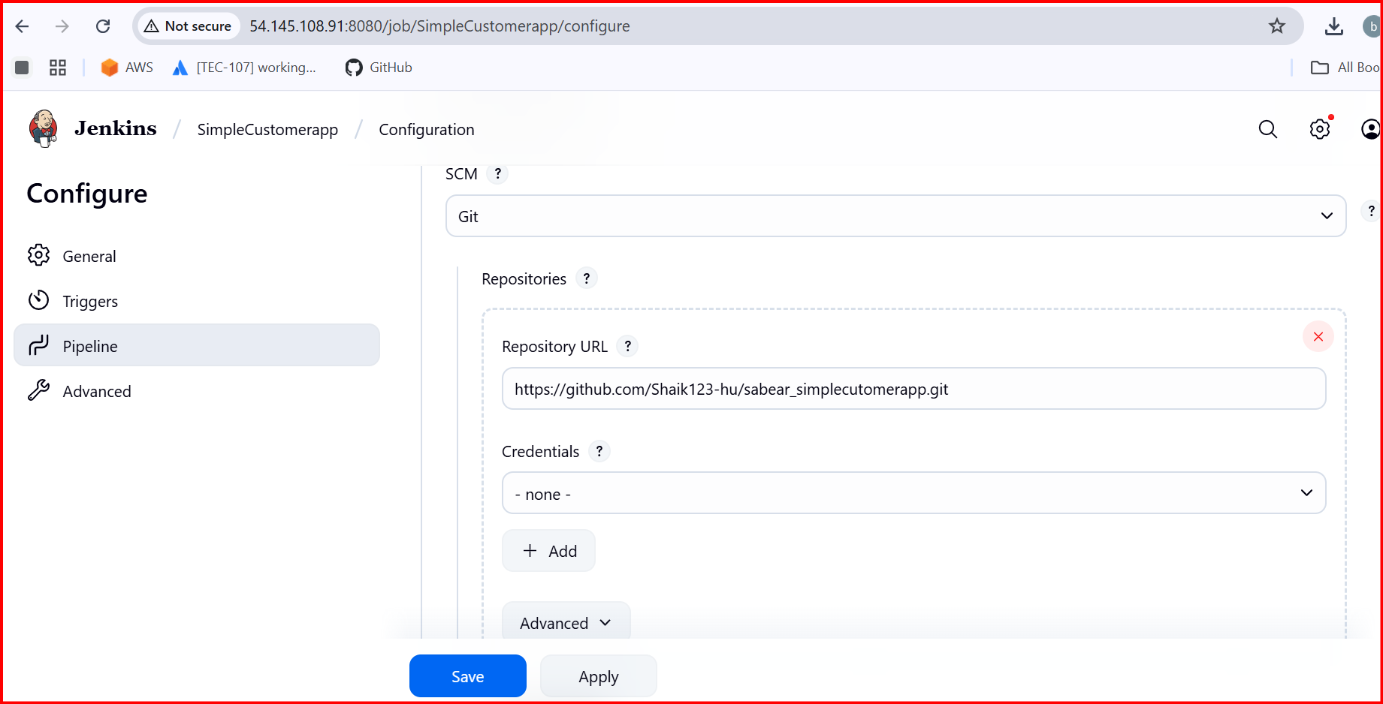

**Branch Specifier (blank for 'any')**

**\*/feature-1.1**

**Add sonarqube server to Jenkins**

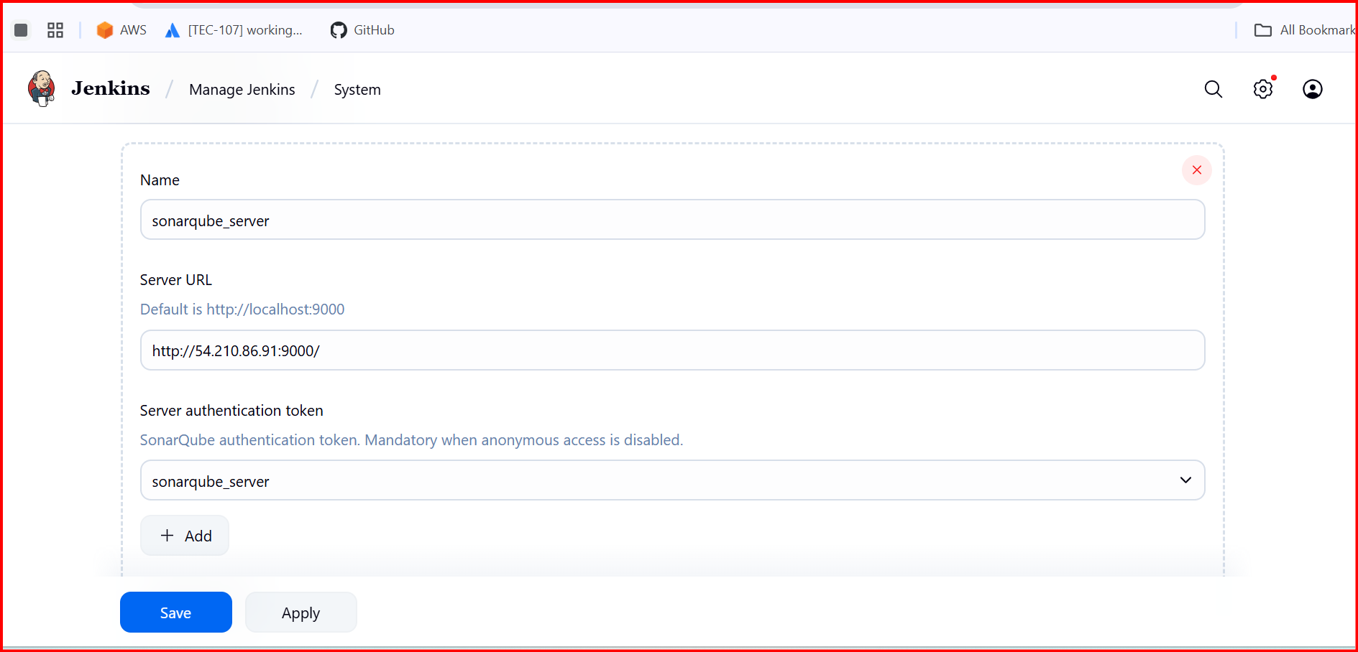

**Git**

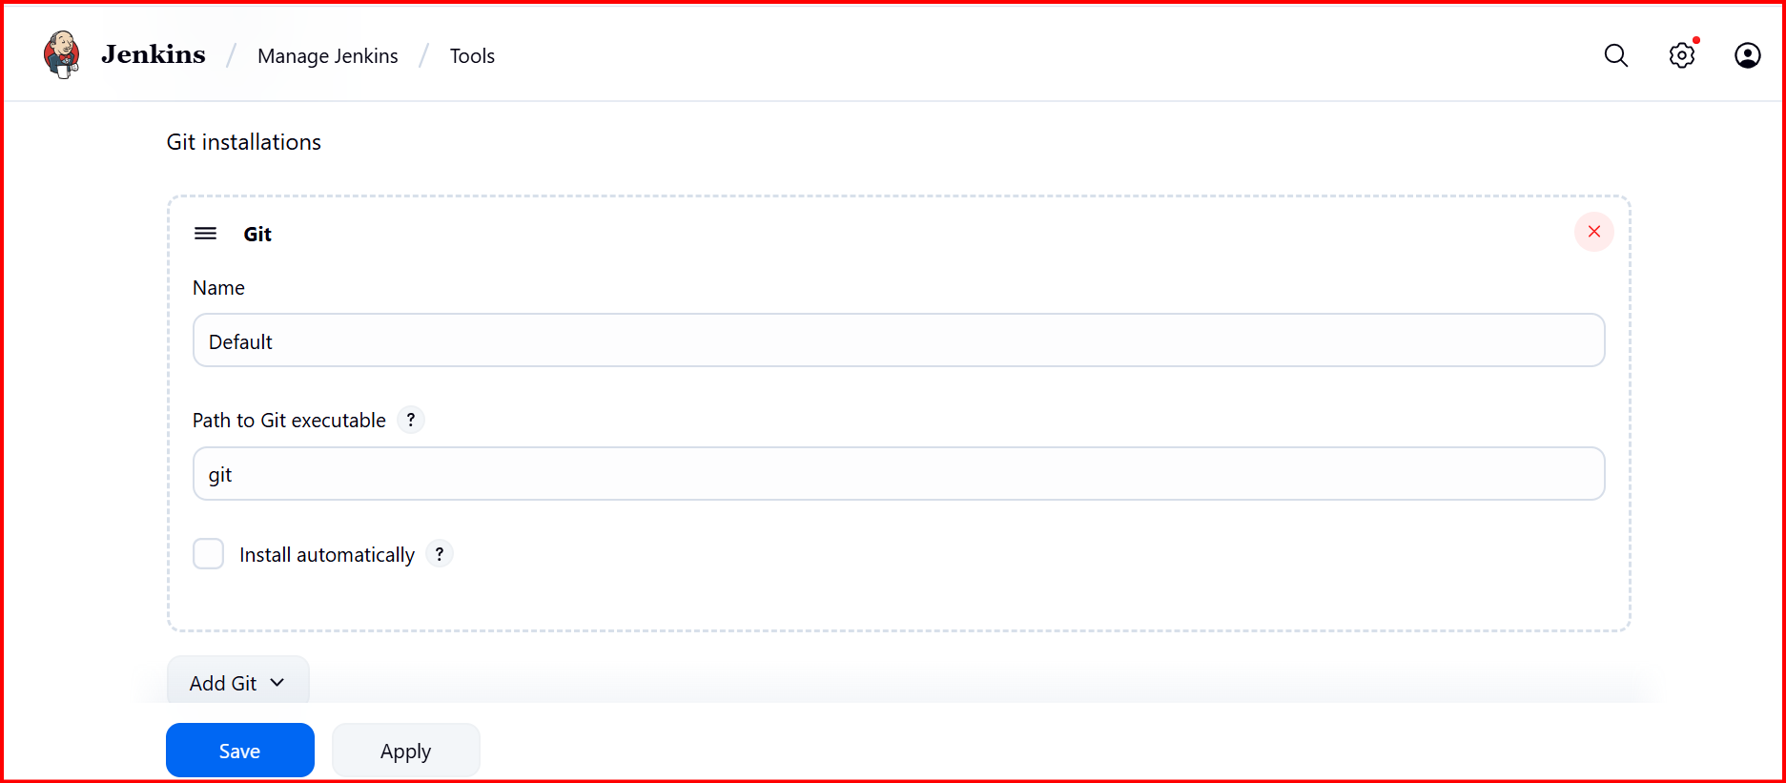

**Sonar scanner**

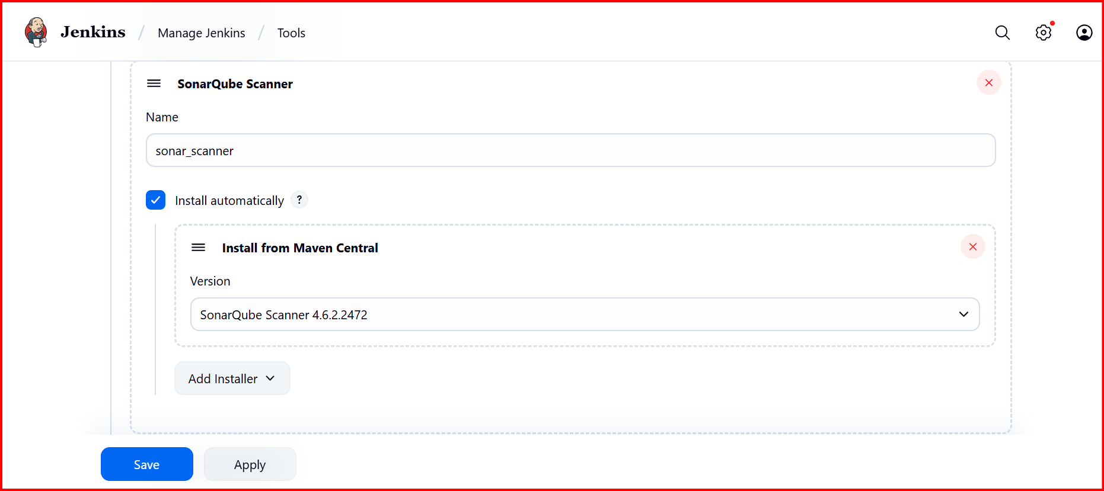

**Maven**

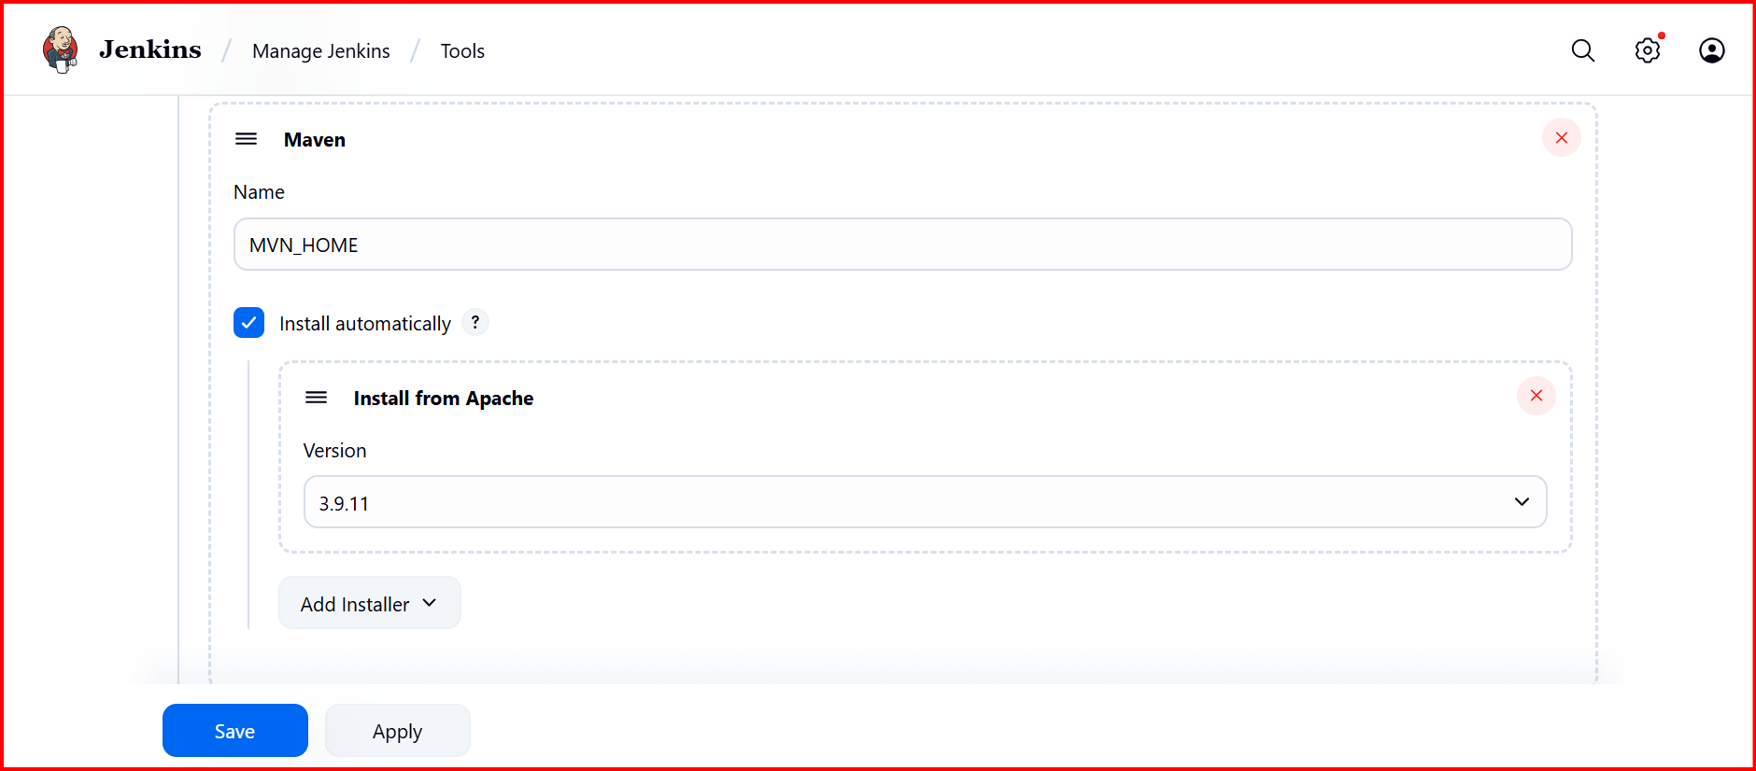

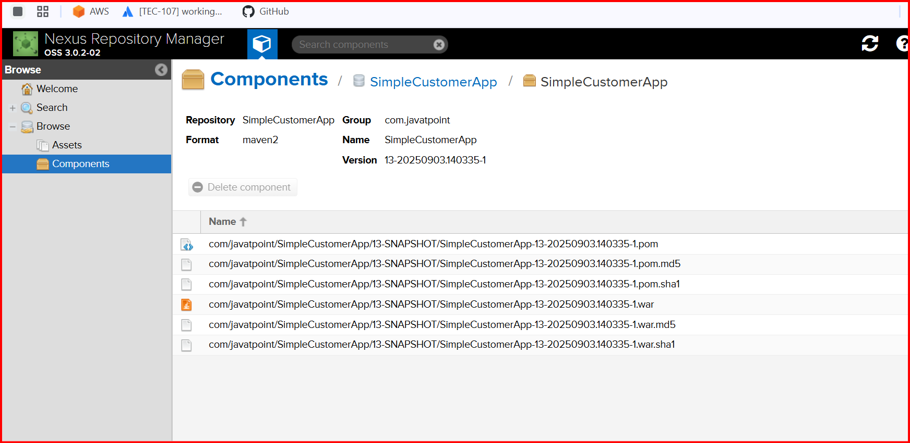

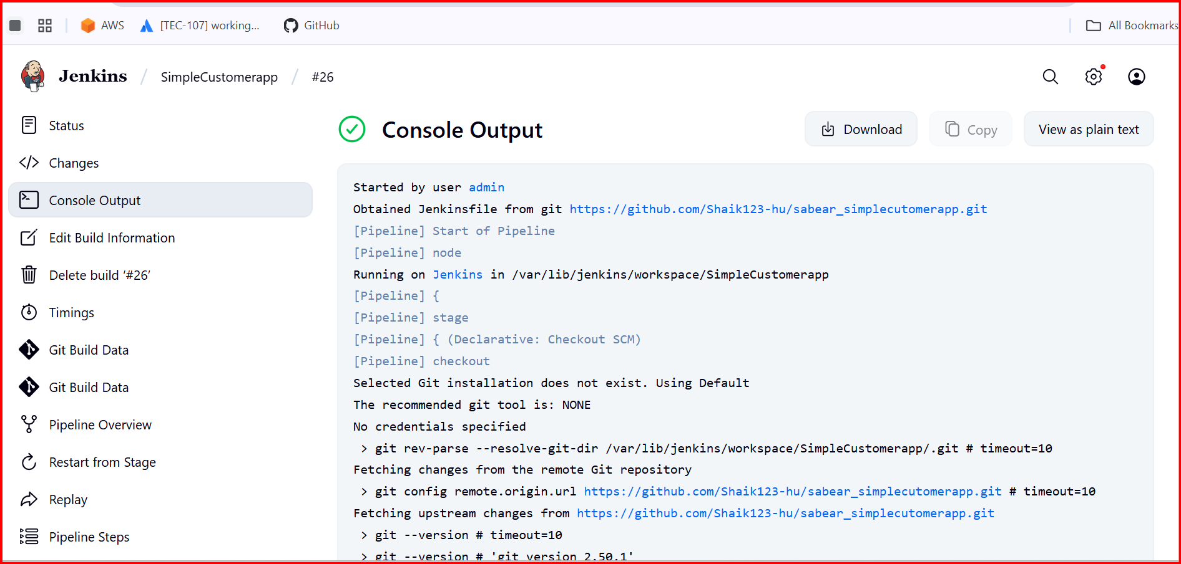

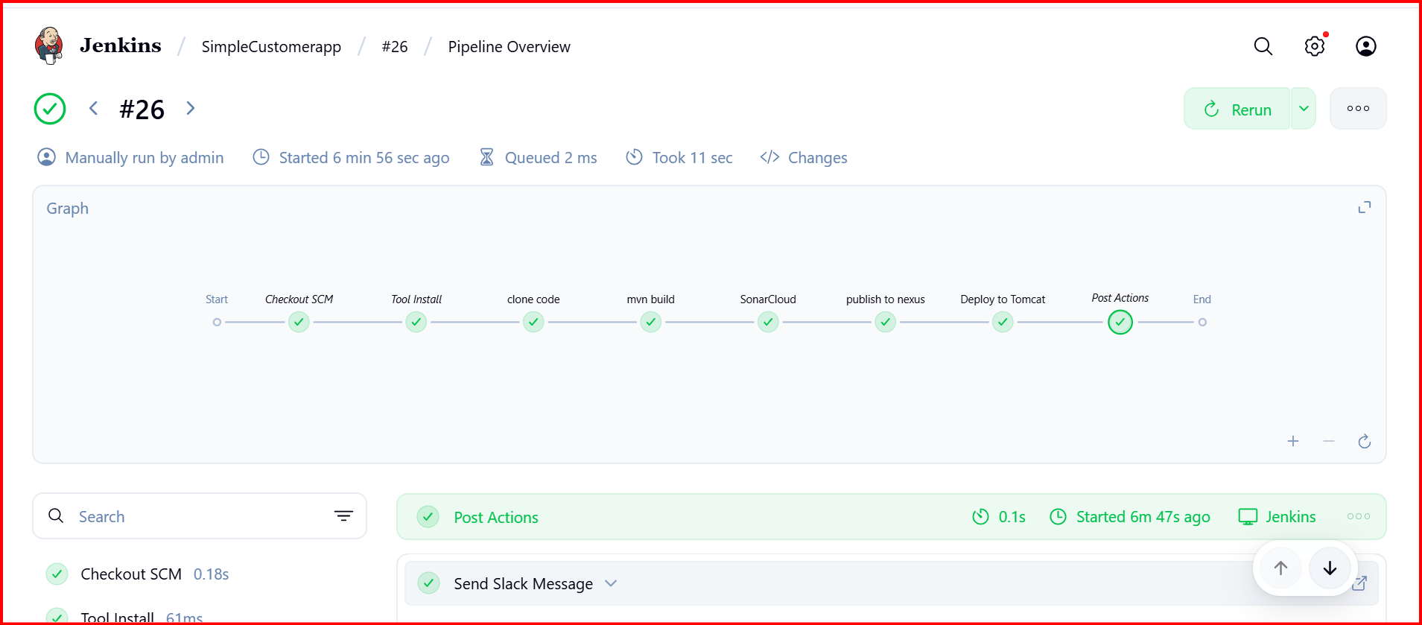

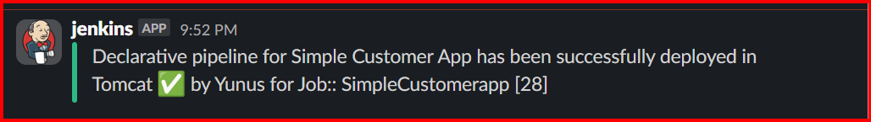

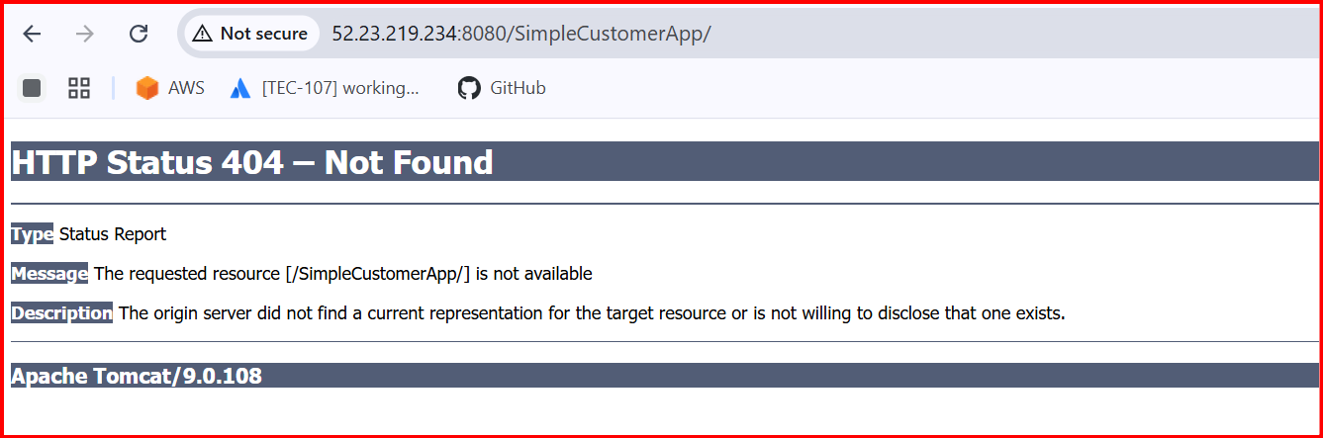

**3) Setup a jenkins CICD pipeline using Scripted pipeline using feature-1.1 branch.**[**https://github.com/betawins/sabear_simplecutomerapp/tree/feature-1.1**](https://github.com/betawins/sabear_simplecutomerapp/tree/feature-1.1) **stages:  
   1) Git Clone  
   2) Sonarqube Integration  
   3) Maven Compilation  
   4) Nexus Artifactory  
   5) Slack Notification  
   6) Deploy On tomcat**

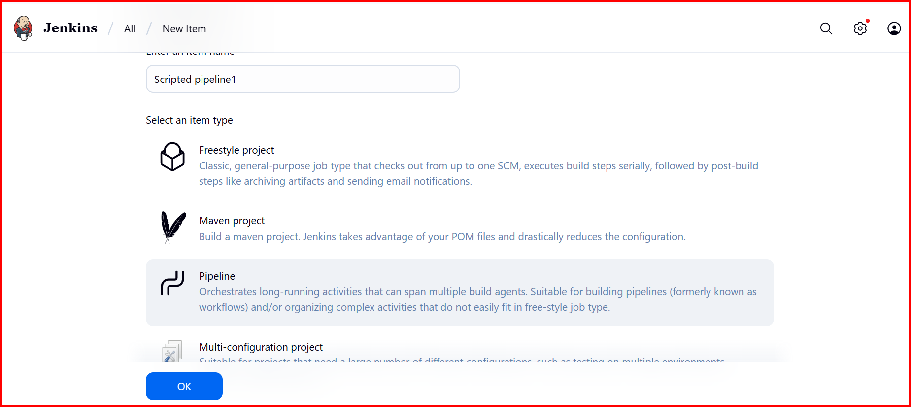

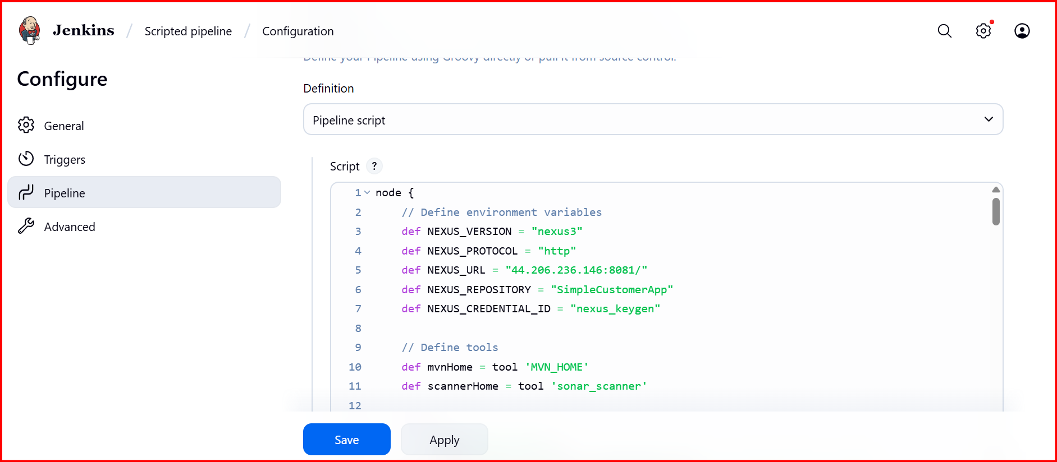

**node {**

**// Define environment variables**

**def NEXUS_VERSION = "nexus3"**

**def NEXUS_PROTOCOL = "http"**

**def NEXUS_URL = "44.206.236.146:8081/"**

**def NEXUS_REPOSITORY = "SimpleCustomerApp"**

**def NEXUS_CREDENTIAL_ID = "nexus_keygen"**

**// Define tools**

**def mvnHome = tool 'MVN_HOME'**

**def scannerHome = tool 'sonar_scanner'**

**try {**

**stage('Clone Code') {**

**git 'https://github.com/Shaik123-hu/sabear_simplecutomerapp.git'**

**}**

**stage('Maven Build') {**

**sh "${mvnHome}/bin/mvn -Dmaven.test.failure.ignore=true clean install"**

**}**

**stage('SonarCloud') {**

**withSonarQubeEnv('sonarqube_server') {**

**// Define directories**

**def sourceDir = "${WORKSPACE}/src/main/java"**

**def webappDir = "${WORKSPACE}/src/main/webapp"**

**def binaryDir = "${WORKSPACE}/target/classes"**

**def reportDir = "${WORKSPACE}/target/surefire-reports"**

**// Determine source directories to analyze**

**def sonarSources = []**

**if (fileExists(sourceDir)) {**

**sonarSources.add(sourceDir)**

**}**

**if (fileExists(webappDir)) {**

**sonarSources.add(webappDir)**

**}**

**if (sonarSources.isEmpty()) {**

**echo "Warning: No source directories (src/main/java or src/main/webapp) found. Skipping SonarQube analysis."**

**return**

**}**

**// Build SonarQube command**

**def sonarCommand = """**

**${scannerHome}/bin/sonar-scanner \**

**-Dsonar.projectKey=Ncodeit \**

**-Dsonar.projectName=Ncodeit \**

**-Dsonar.projectVersion=2.0 \**

**-Dsonar.sources="${sonarSources.join(',')}" \**

**-Dsonar.junit.reportsPath="${reportDir}" \**

**-Dsonar.verbose=true**

**"""**

**// Add binaries only if target/classes exists**

**if (fileExists(binaryDir)) {**

**sonarCommand += " -Dsonar.java.binaries=\"${binaryDir}\""**

**} else {**

**echo "Warning: Binary directory ${binaryDir} does not exist. Skipping Java binaries analysis."**

**}**

**// Execute SonarQube analysis**

**sh sonarCommand**

**}**

**}**

**stage('Publish to Nexus') {**

**def pom = readMavenPom file: 'pom.xml'**

**def groupId = pom.groupId**

**def artifactId = pom.artifactId**

**// Use a fallback version if ${BUILD_NUMBER} causes issues**

**def version = pom.version.replace('${BUILD_NUMBER}', env.BUILD_NUMBER ?: '3')**

**def packaging = pom.packaging**

**def filesByGlob = findFiles(glob: "target/*.${packaging}")**

**if (filesByGlob.length == 0) {**

**error "*** No artifact found in target/*.${packaging}"**

**}**

**def artifactPath = filesByGlob[0].path**

**if (fileExists(artifactPath)) {**

**echo "*** Uploading ${artifactPath} to Nexus (group: ${groupId}, version: ${version}, packaging: ${packaging})"**

**nexusArtifactUploader(**

**nexusVersion: NEXUS_VERSION,**

**protocol: NEXUS_PROTOCOL,**

**nexusUrl: NEXUS_URL,**

**groupId: groupId,**

**version: version,**

**repository: NEXUS_REPOSITORY,**

**credentialsId: NEXUS_CREDENTIAL_ID,**

**artifacts: [**

**[artifactId: artifactId, classifier: '', file: artifactPath, type: packaging],**

**[artifactId: artifactId, classifier: '', file: 'pom.xml', type: 'pom']**

**]**

**)**

**} else {**

**error "*** File: ${artifactPath}, could not be found"**

**}**

**}**

**stage('Deploy to Tomcat') {**

**withCredentials([usernamePassword(credentialsId: 'tomcat', usernameVariable: 'TOMCAT_USER', passwordVariable: 'TOMCAT_PASS')]) {**

**def warFile = sh(script: "ls target/*.war | head -n 1", returnStdout: true).trim()**

**echo "Deploying ${warFile} to Tomcat at context path /SimpleCustomerApp..."**

**sh """**

**curl -u ${TOMCAT_USER}:${TOMCAT_PASS} \**

**-T ${warFile} \**

**"http://52.23.219.234:8080/manager/text/deploy?path=/SimpleCustomerApp&update=true"**

**"""**

**}**

**}**

**// Success notification**

**slackSend(**

**channel: '#jenkins-integration',**

**color: 'good',**

**message: "Scripted pipeline for Simple Customer App has been successfully deployed in Tomcat :white_check_mark: by Yunus for Job{env.JOB_NAME} [${env.BUILD_NUMBER}]",**

**tokenCredentialId: 'Slackid'**

**)**

**} catch (e) {**

**// Failure notification**

**slackSend(**

**channel: '#jenkins-integration',**

**color: 'danger',**

**message: "❌ Build/Deploy Failed: ${env.JOB_NAME} [${env.BUILD_NUMBER}]",**

**tokenCredentialId: 'Slackid'**

**)**

**throw e**

**}**

**}**

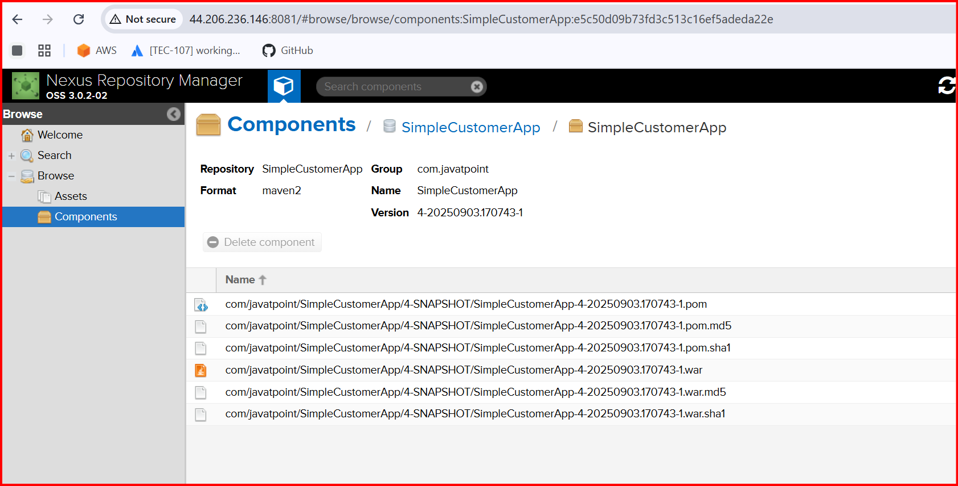

**Other configuration as above**

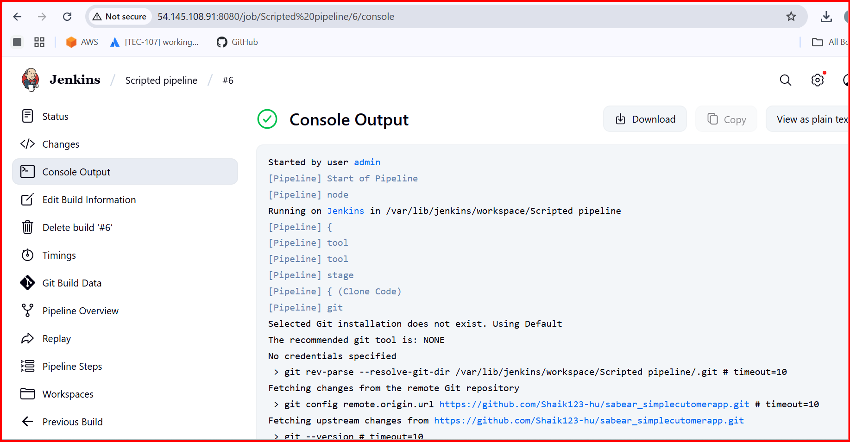

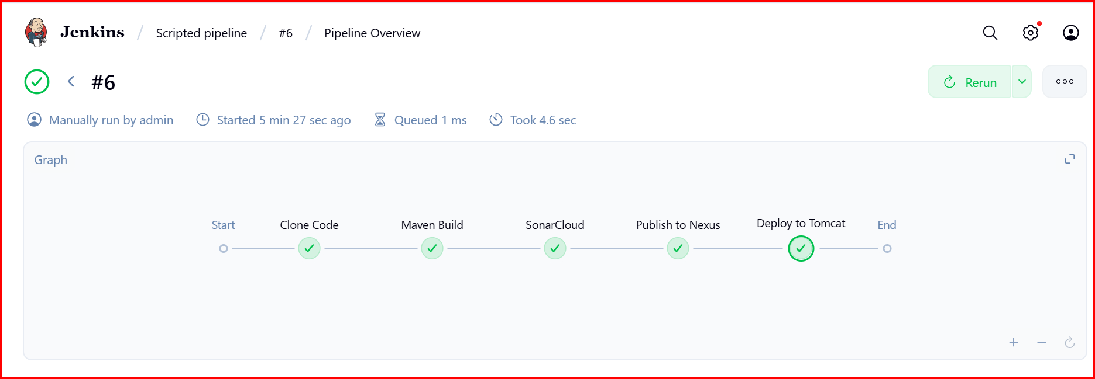

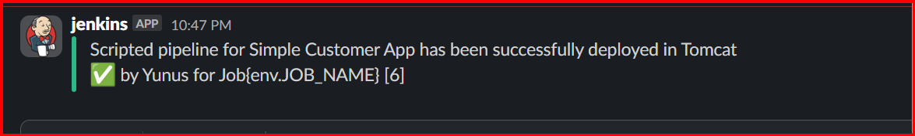

**4) Write sample skeleton of pipelines.**

**Scripted Pipeline**

**This offers more flexibility and control, using Groovy scripting.**

**While powerful, it requires a deeper understanding of Groovy and Jenkins internals**

**Scripted Pipeline Skeleton**

**node {**

**// Define tools and env if needed**

**def mvnHome = tool name: 'MVN_HOME', type: 'maven'**

**stage('Checkout') {**

**git branch: 'feature-1.1',**

**url: 'https://github.com/your-repo/your-project.git'**

**}**

**stage('Build') {**

**sh "${mvnHome}/bin/mvn clean install -DskipTests=true"**

**}**

**stage('SonarQube Analysis') {**

**withSonarQubeEnv('sonarqube_server') {**

**sh "${mvnHome}/bin/mvn sonar:sonar"**

**}**

**}**

**stage('Publish to Nexus') {**

**sh "${mvnHome}/bin/mvn deploy"**

**}**

**stage('Deploy to Tomcat') {**

**sh "cp target/*.war /opt/tomcat/webapps/"**

**}**

**stage('Notify Slack') {**

**slackSend channel: '#jenkins-integration',**

**color: 'good',**

**message: "✅ Build & Deploy successful!"**

**}**

**}**

**Declarative Pipeline Skeleton**

**a) Declarative Pipeline**

**This is a more structured and opinionated syntax, making it easier to read and maintain.**

**This structure is ideal for most use cases and is recommended for new users.**

**pipeline {**

**agent any**

**tools {**

**maven "MVN_HOME"**

**}**

**environment {**

**BRANCH_NAME = "feature-1.1"**

**SONARQUBE_ENV = "sonarqube_server"**

**}**

**stages {**

**stage('Checkout') {**

**steps {**

**git branch: "${BRANCH_NAME}",**

**url: 'https://github.com/your-repo/your-project.git'**

**}**

**}**

**stage('Build') {**

**steps {**

**sh "mvn clean install -DskipTests=true"**

**}**

**}**

**stage('SonarQube Analysis') {**

**steps {**

**withSonarQubeEnv("${SONARQUBE_ENV}") {**

**sh "mvn sonar:sonar"**

**}**

**}**

**}**

**stage('Publish to Nexus') {**

**steps {**

**sh "mvn deploy"**

**}**

**}**

**stage('Deploy to Tomcat') {**

**steps {**

**sh "cp target/*.war /opt/tomcat/webapps/"**

**}**

**}**

**stage('Notify Slack') {**

**steps {**

**slackSend(channel: '#jenkins-integration',**

**color: 'good',**

**message: "✅ Build & Deploy successful!")**

**}**

**}**

**}**

**}**

**5.Create a parametirized job in Jenkins**

**The job accepts inputs (parameters) from the user before it runs, and those inputs control how the pipeline behaves**

**🚀 Jenkins – Create a Parameterized Pipeline Job**

**Access Jenkins**

**Login Jenkins**

**1. Create a New Pipeline Job**

* **From the Jenkins Dashboard, click “New Item”.**
* **Enter a job name → Parameterized.**
* **Select Pipeline**
* **Click OK.**

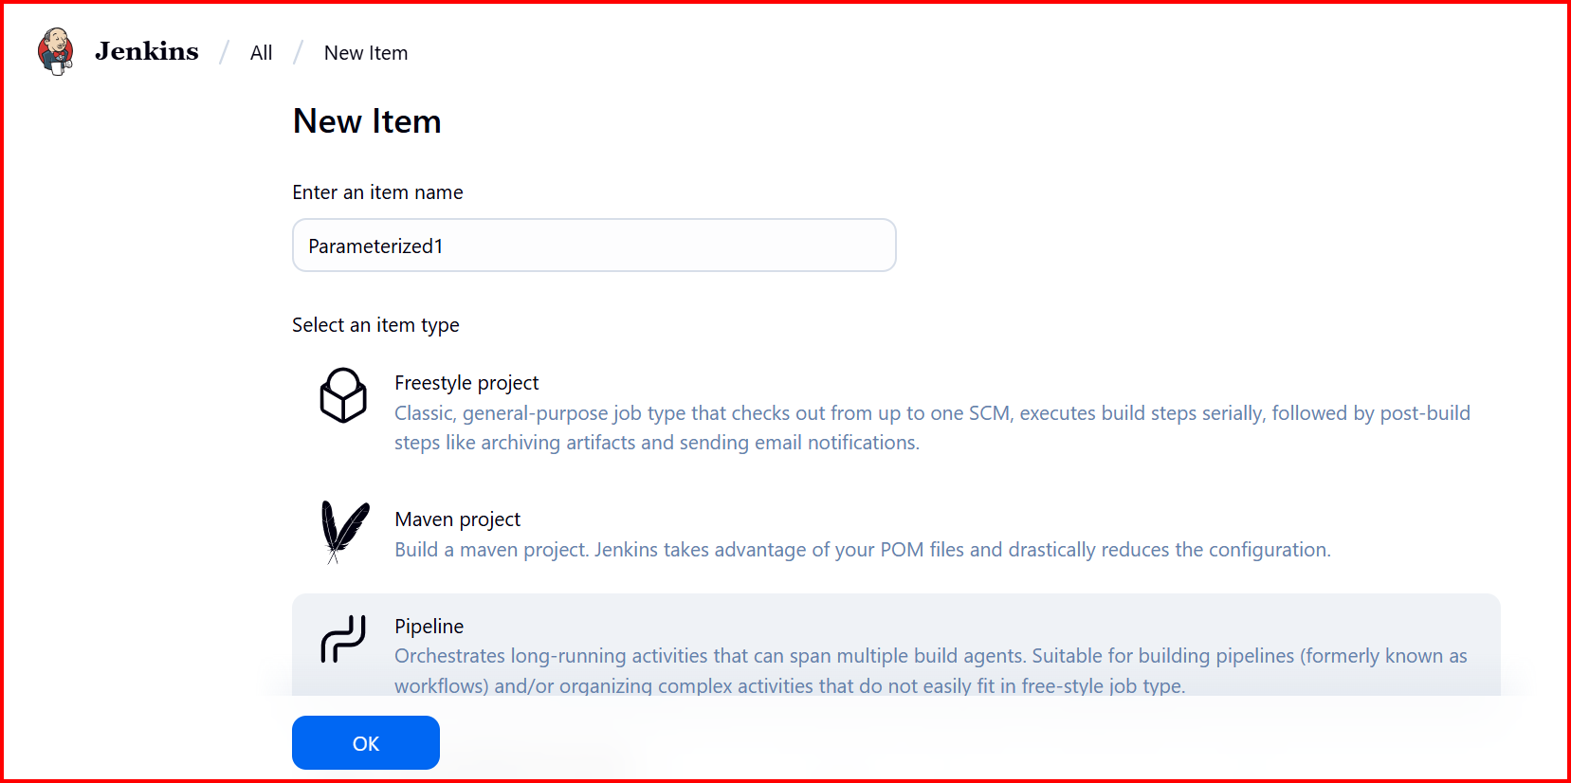

**2.Add Parameters**

* **In the job configuration page, check ✅ This project is parameterized.**
* **Add parameters as needed:**
  + **String Parameter**
    - **Name: BRANCH_NAME**
    - **Default Value: master**
    - **Description: Git branch to build.**

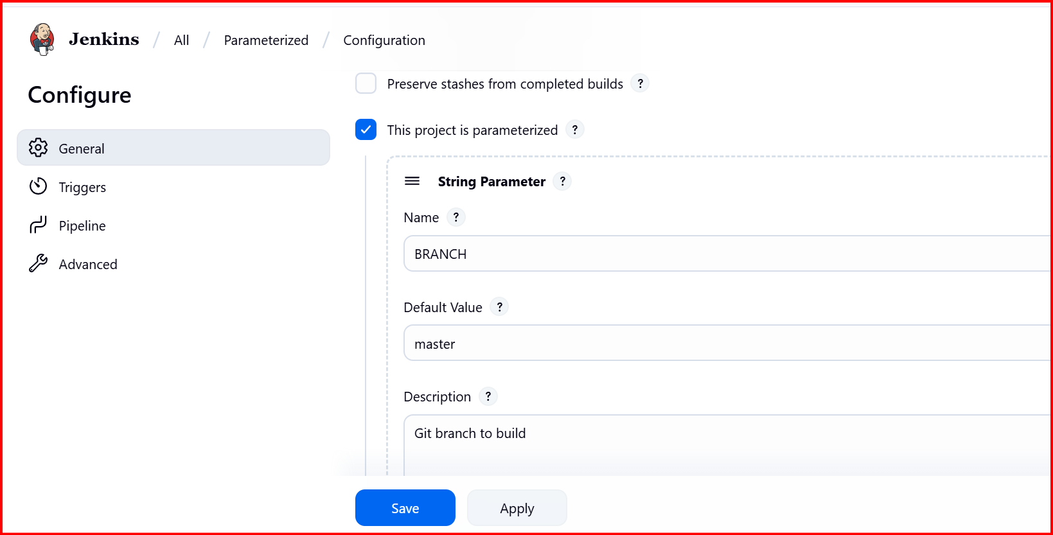

**3.add choice parameter**

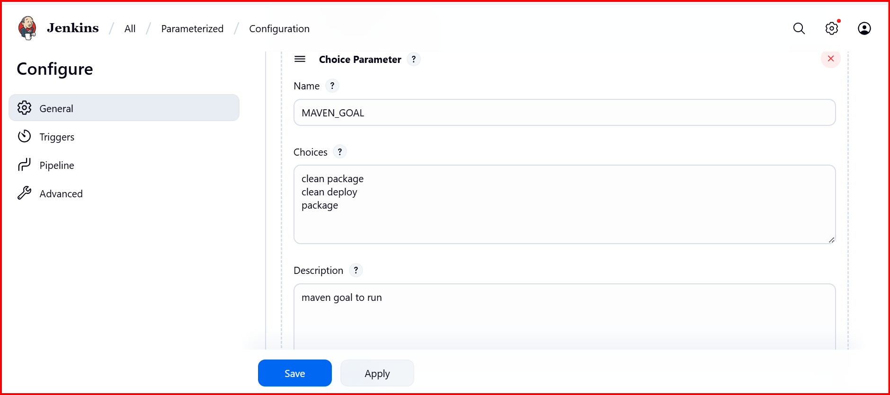

**4.add Boolean parameter**

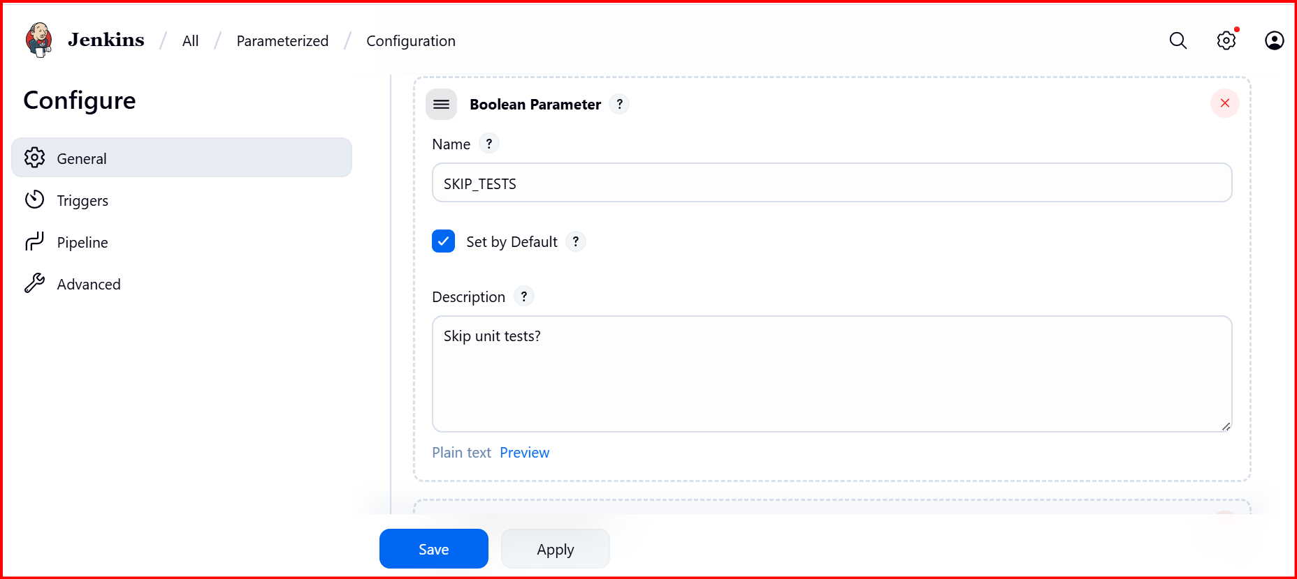

**5. add Boolean parameter**

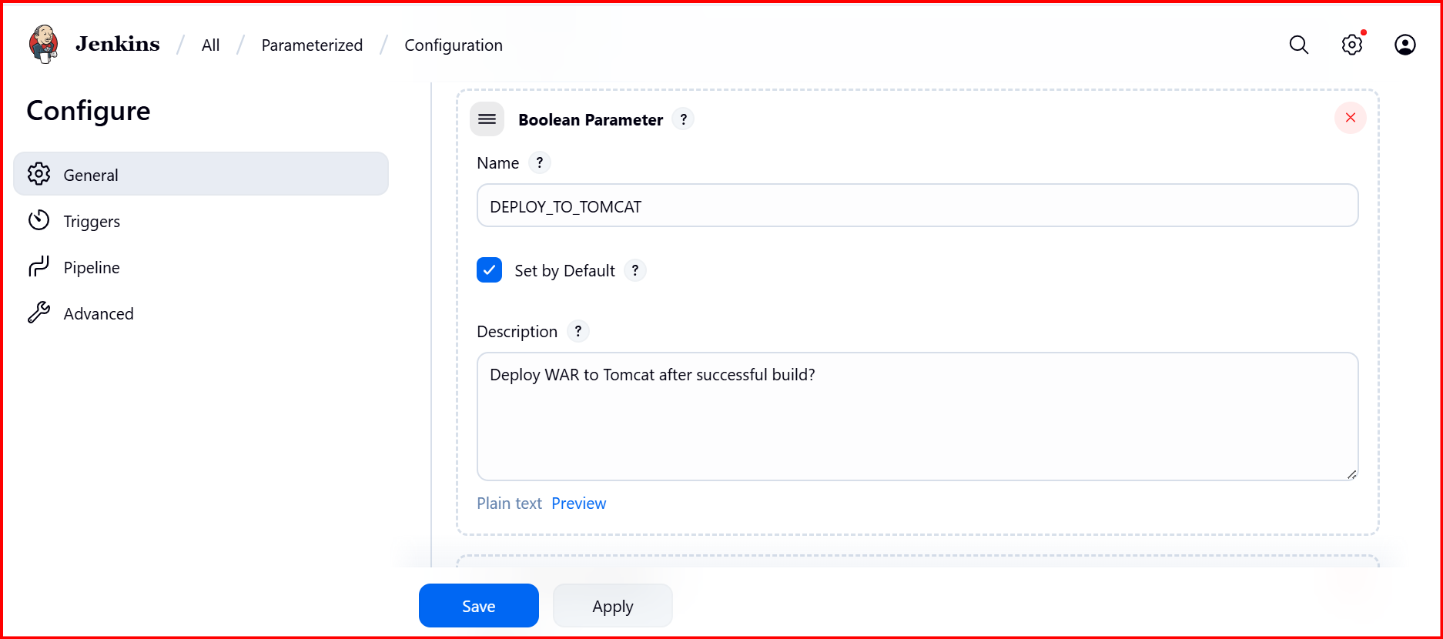

**6.Add ch0ice Parameter**

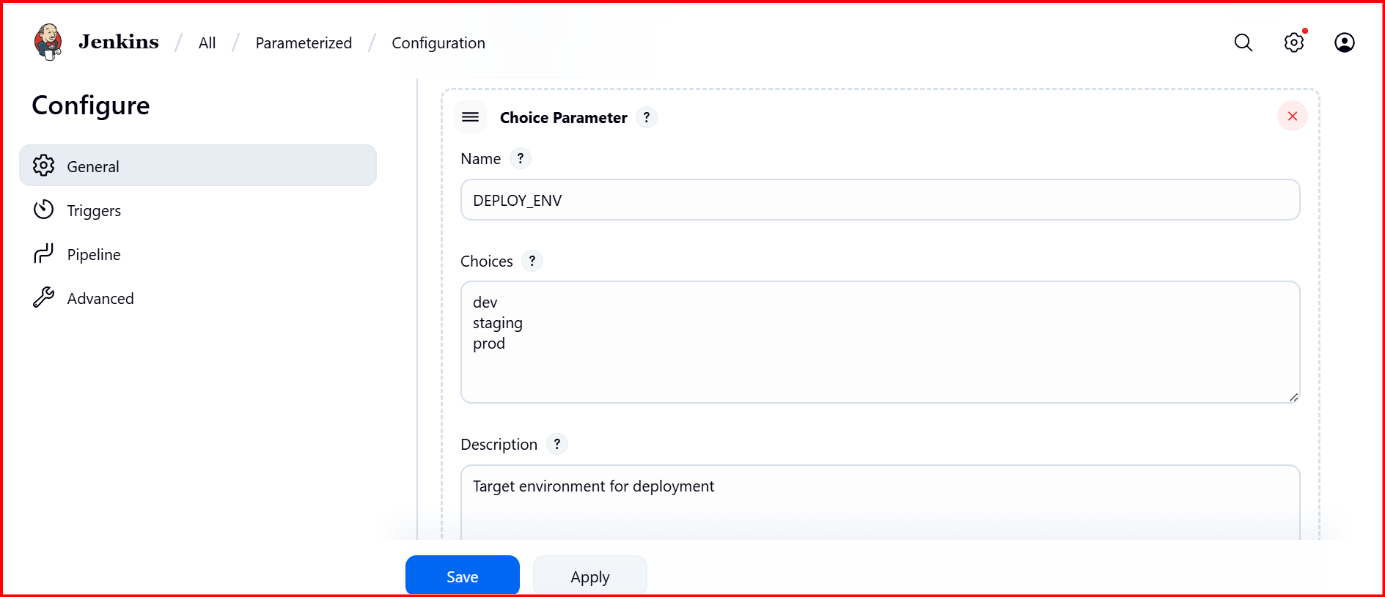

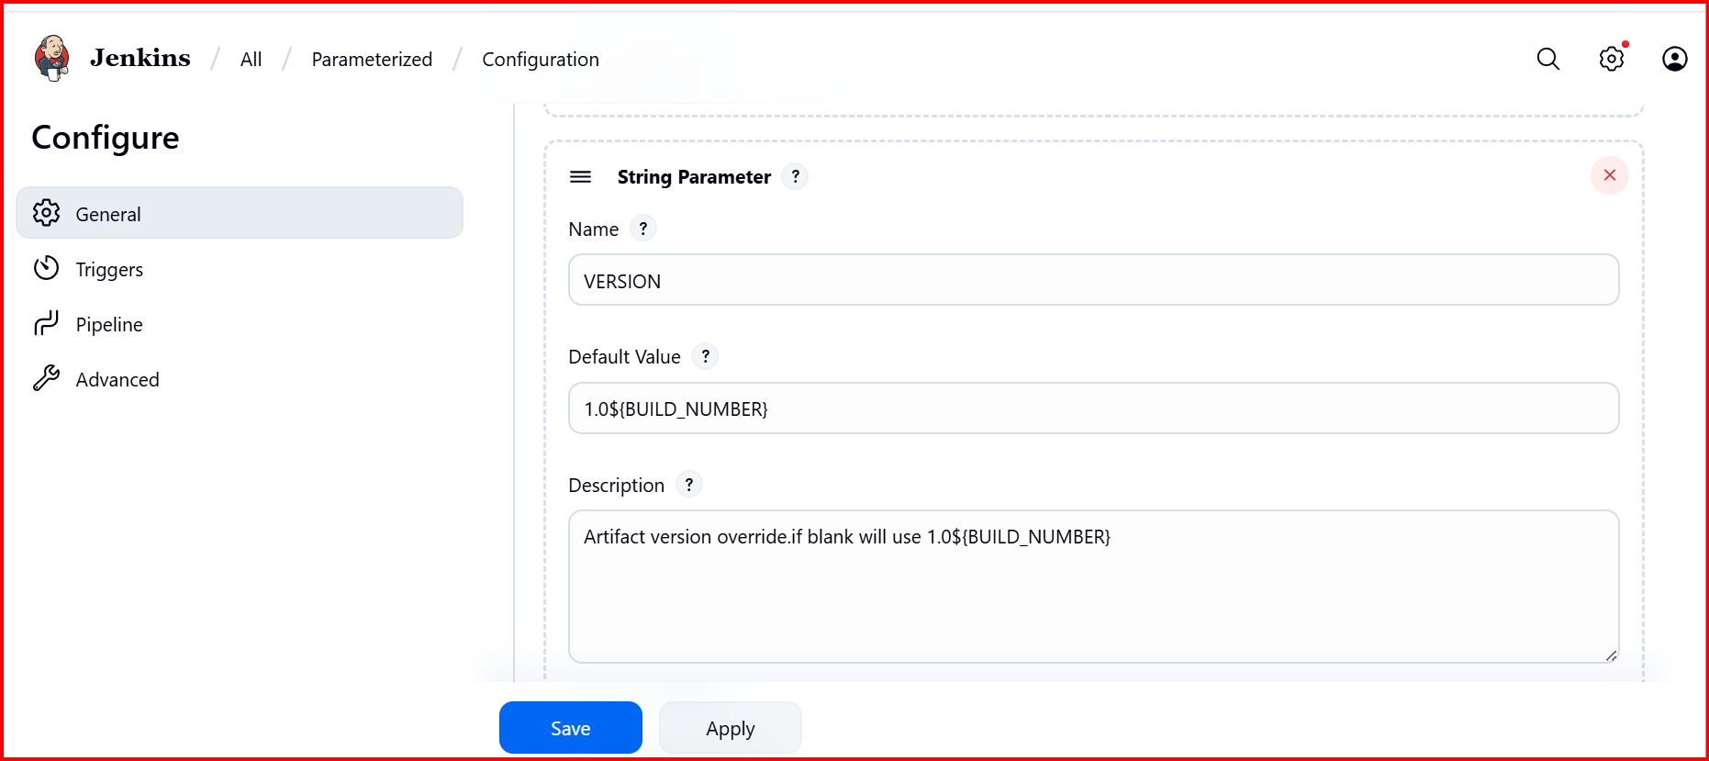

**Add your script**

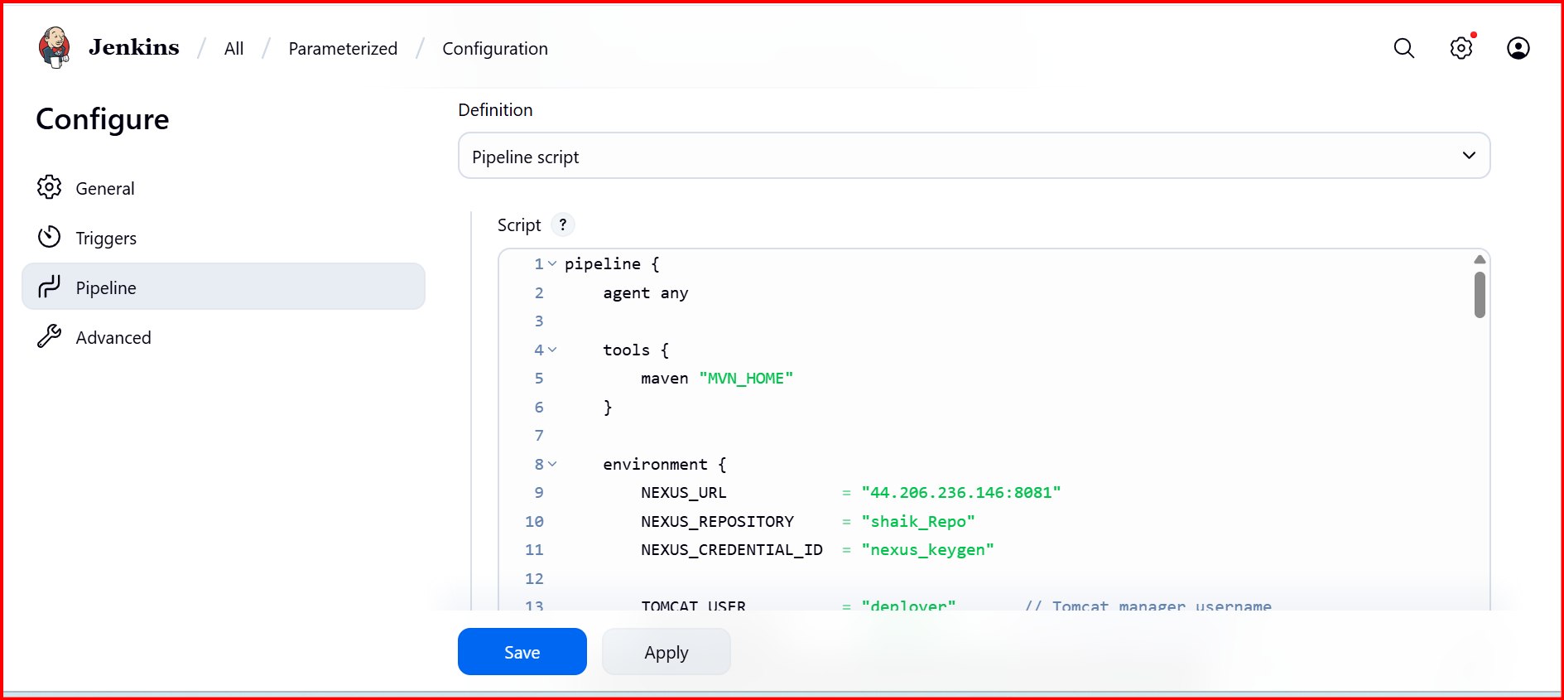

**pipeline {**

**agent any**

**tools {**

**maven "MVN_HOME"**

**}**

**environment {**

**NEXUS_URL = "44.206.236.146:8081"**

**NEXUS_REPOSITORY = "shaik_Repo"**

**NEXUS_CREDENTIAL_ID = "nexus_keygen"**

**TOMCAT_USER = "deployer" // Tomcat manager username**

**TOMCAT_PASSWORD = "deployer" // Tomcat manager password**

**TOMCAT_HOST = "52.23.219.234" // Tomcat EC2 public IP**

**TOMCAT_PORT = "8080"**

**SLACK_CHANNEL = "#jenkins-integration"**

**SLACK_CREDENTIAL_ID = "slack_notification"**

**}**

**stages {**

**stage("Clone code") {**

**steps {**

**git 'https://github.com/Shaik123-hu/spring3-mvc-maven-xml-hello-world-1.git'**

**}**

**}**

**stage("Maven build") {**

**steps {**

**sh 'mvn -B -Dmaven.test.failure.ignore=true clean install'**

**}**

**}**

**stage('Publish to Nexus') {**

**steps {**

**script {**

**def pom = readMavenPom file: 'pom.xml'**

**def artifactVersion = pom.version**

**def groupId = pom.groupId**

**def artifactId = pom.artifactId**

**def warFiles = findFiles(glob: "target/${artifactId}-${artifactVersion}.war")**

**if (warFiles.length == 0) {**

**error "WAR file not found: target/${artifactId}-${artifactVersion}.war"**

**}**

**def warFile = warFiles[0].path**

**echo "Uploading artifact: ${warFile} (version: ${artifactVersion}) to Nexus"**

**nexusArtifactUploader(**

**artifacts: [[**

**artifactId: artifactId,**

**classifier: '',**

**file: warFile,**

**type: 'war'**

**], [**

**artifactId: artifactId,**

**classifier: '',**

**file: 'pom.xml',**

**type: 'pom'**

**]],**

**credentialsId: NEXUS_CREDENTIAL_ID,**

**groupId: groupId,**

**version: artifactVersion,**

**repository: NEXUS_REPOSITORY**

**)**

**}**

**}**

**}**

**stage("Deploy to Tomcat") {**

**steps {**

**script {**

**def pom = readMavenPom file: 'pom.xml'**

**def artifactVersion = pom.version**

**def artifactId = pom.artifactId**

**def warFile = "target/${artifactId}-${artifactVersion}.war"**

**echo "Deploying ${warFile} to Tomcat at ${TOMCAT_HOST}:${TOMCAT_PORT}"**

**sh """**

**curl -u ${TOMCAT_USER}:${TOMCAT_PASSWORD} \**

**-T ${warFile} \**

**"http://${TOMCAT_HOST}:${TOMCAT_PORT}/manager/text/deploy?path=/${artifactId}&update=true"**

**"""**

**}**

**}**

**}**

**}**

**post {**

**success {**

**slackSend(**

**channel: SLACK_CHANNEL,**

**color: 'good',**

**message: "✅ Pipeline '${env.JOB_NAME} [${env.BUILD_NUMBER}]' completed successfully! <${env.BUILD_URL}|Open Build>"**

**)**

**cleanWs()**

**}**

**failure {**

**slackSend(**

**channel: SLACK_CHANNEL,**

**color: 'danger',**

**message: "❌ Pipeline '${env.JOB_NAME} [${env.BUILD_NUMBER}]' failed! <${env.BUILD_URL}|Open Build>"**

**)**

**cleanWs()**

**}**

**always {**

**echo "Cleaning workspace..."**

**cleanWs()**

**}**

**}**

**}**

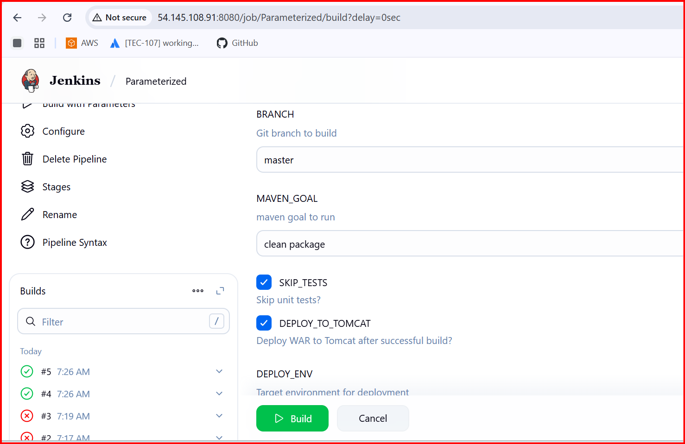

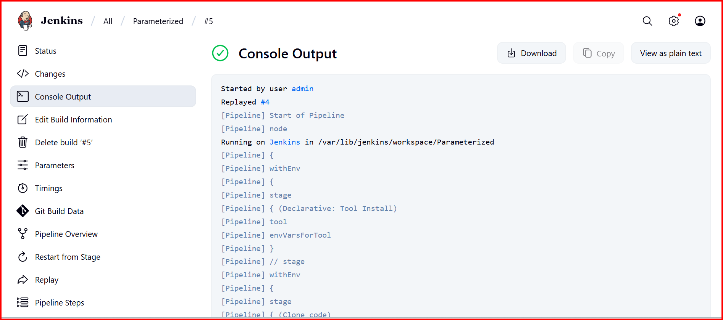

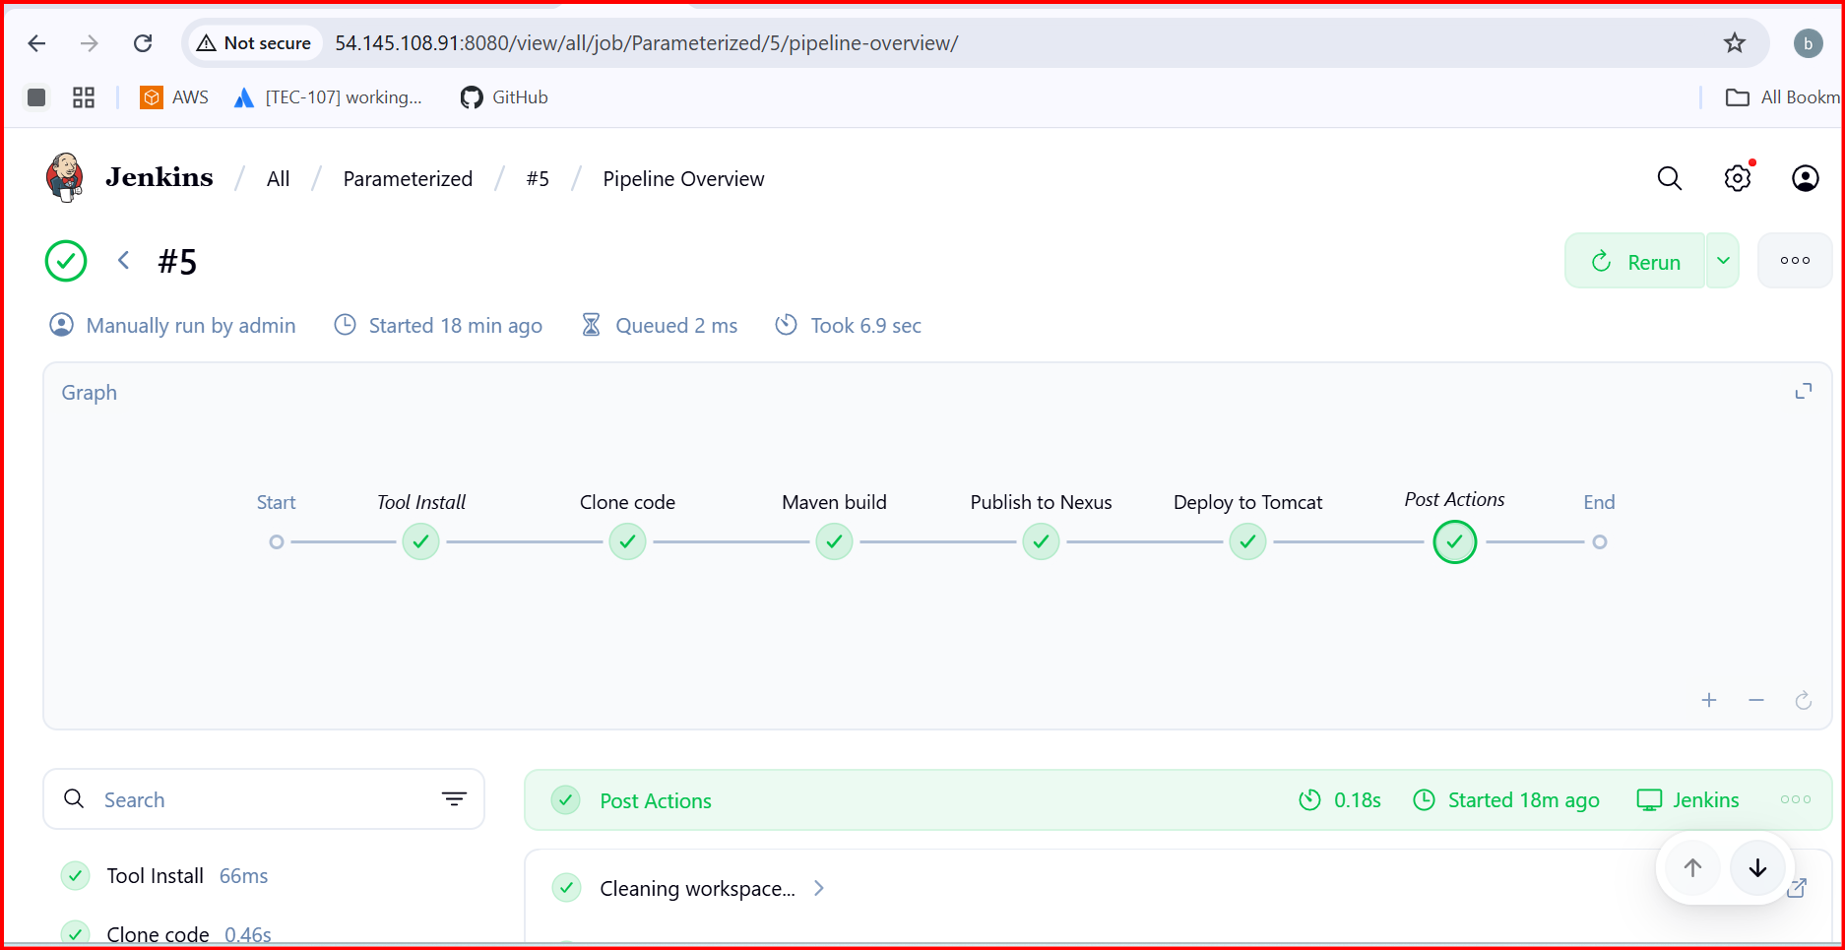

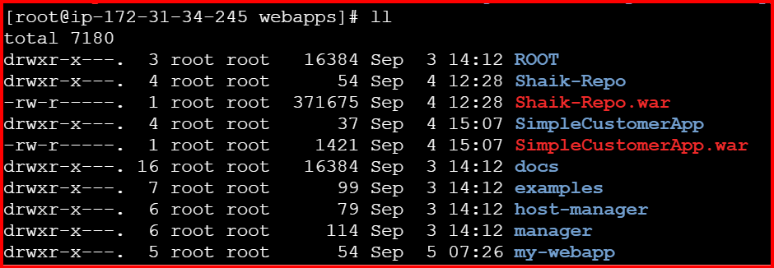

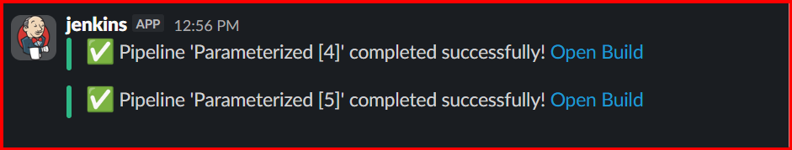

**6.Setup one slave machine for jenkins.**

**Setup two machines 1 Slave 2 Master**

**In Both machines Install Java**

**In Master Machine Jenkins to be install**

1. **sudo dnf install -y java-17-amazon-corretto**
2. **mkdir jenkinsremote**
3. **chmod 777 jenkinsremote**
4. **pwd**

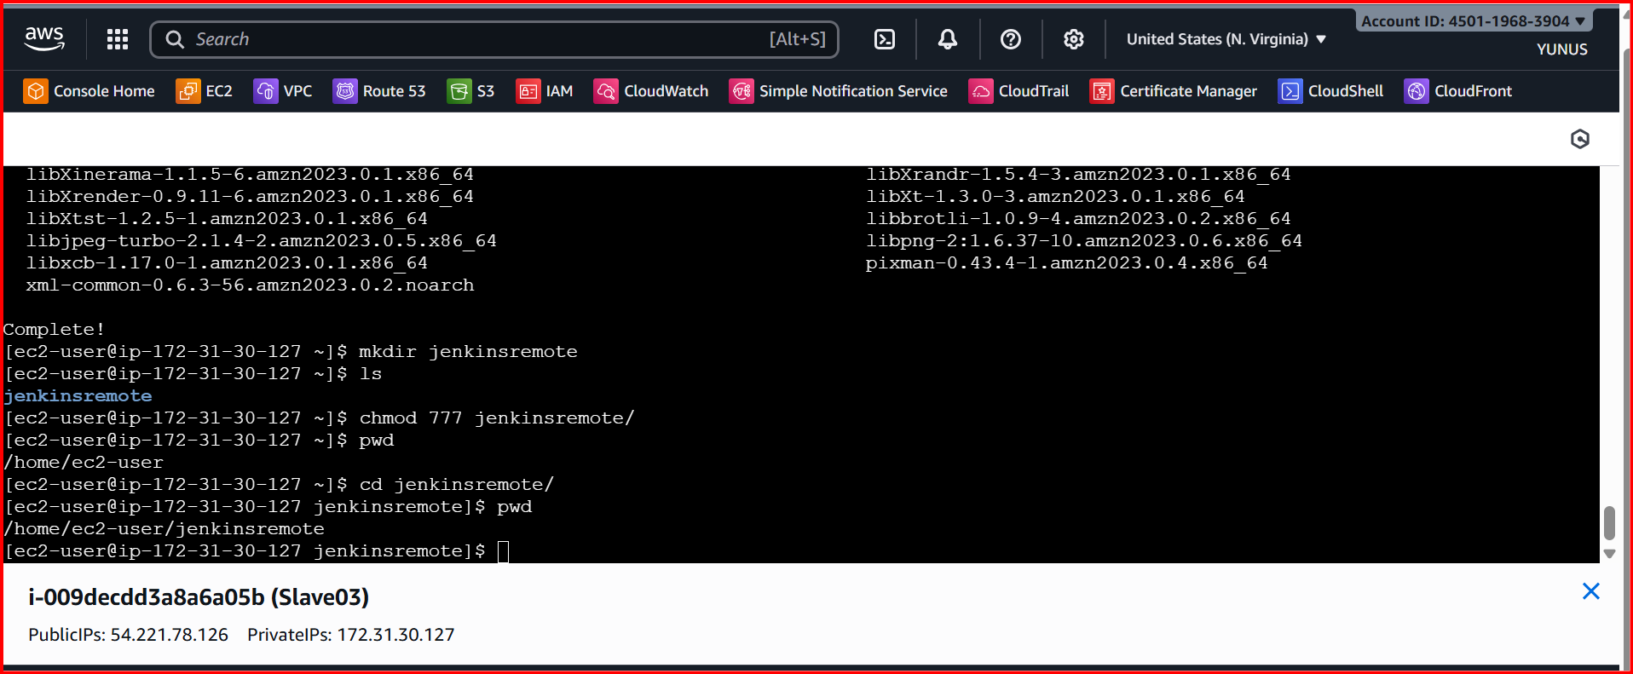

**Go manage Jenkins 🡪 Nodes**

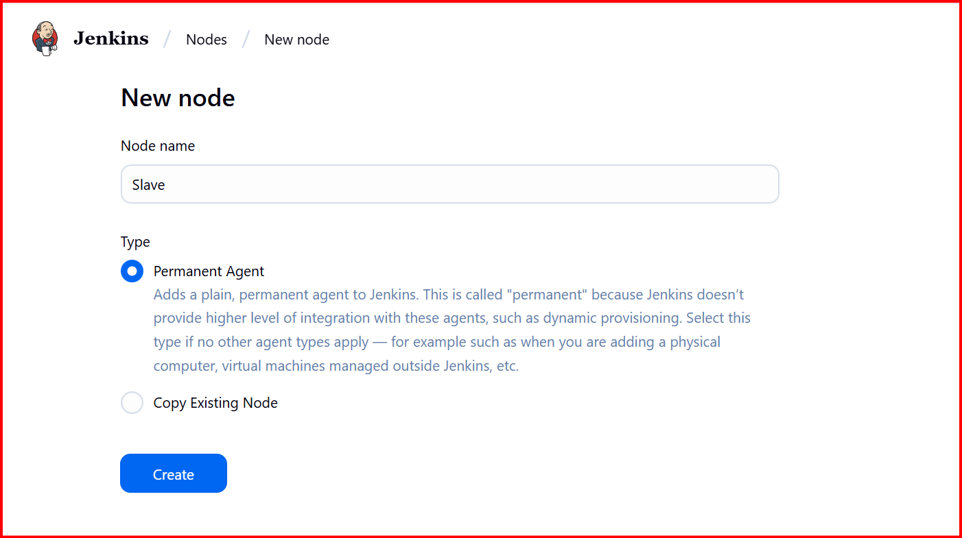

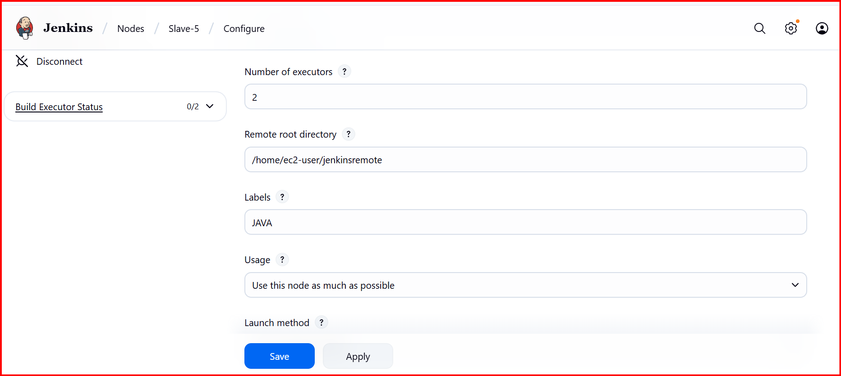

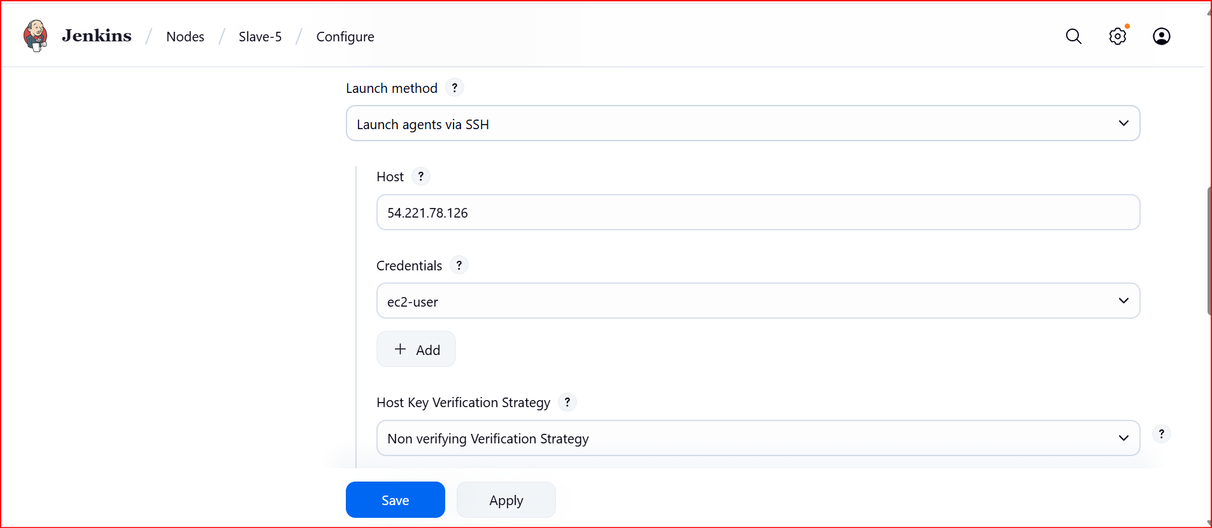

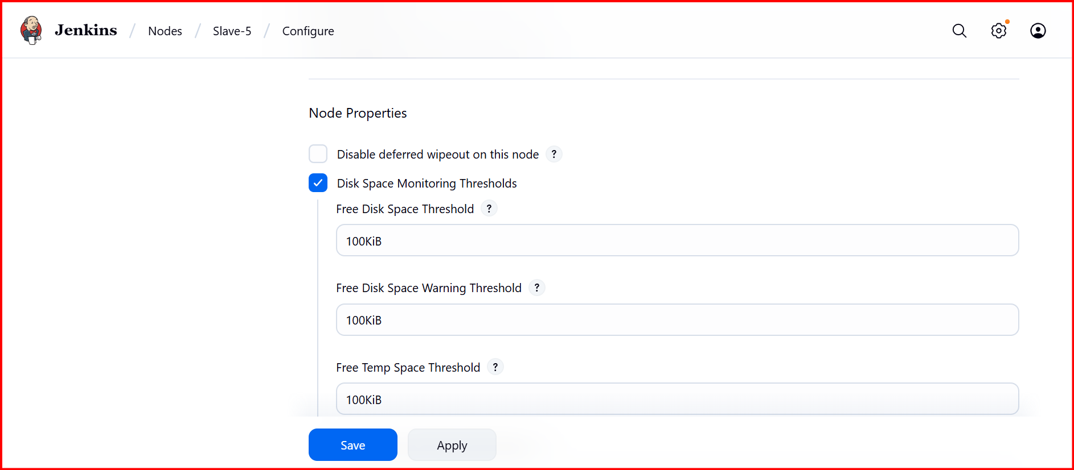

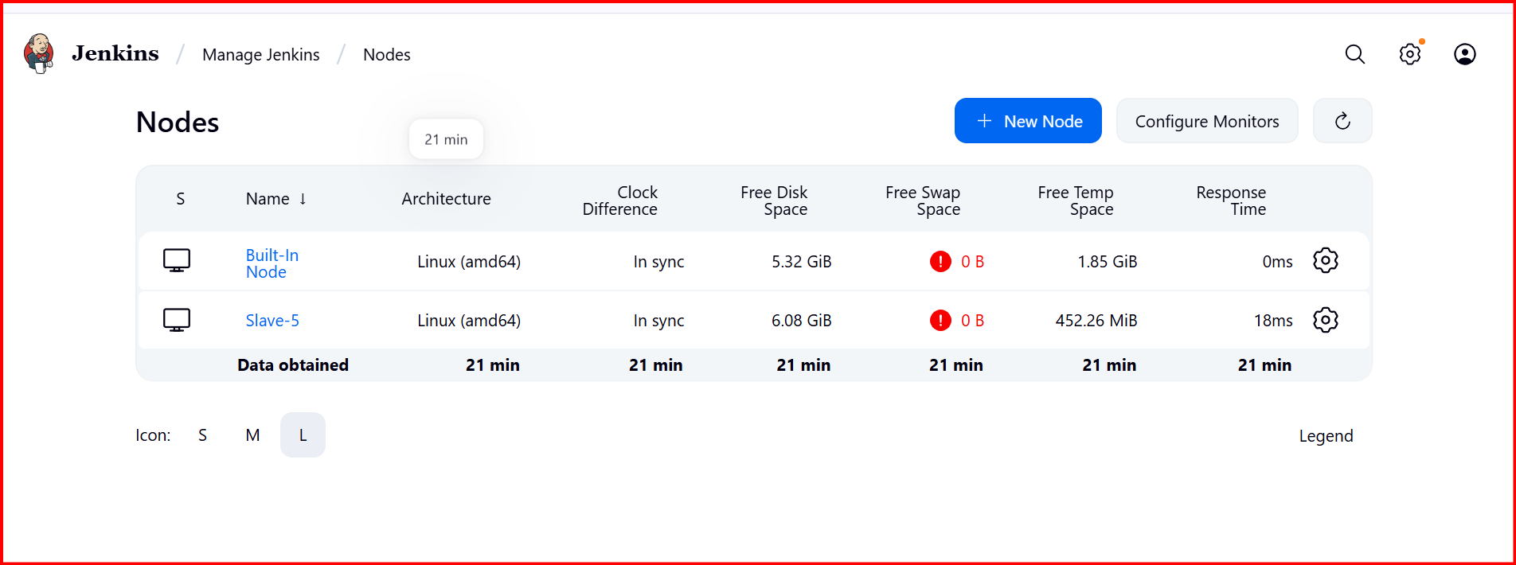

**Run this on Restrict where this project cab be run**

